



Leveraging a Hadoop cluster from SQL Server Integration Services (SSIS)

SQL Server Technical Article

**Published**: October 2012, revised April 2013  
Version: 1.1

**Authors**: Benjamin Guinebertière (Microsoft France), Philippe Beraud (Microsoft France), Rémi Olivier (Microsoft France)

**Technical Reviewers/Contributors**: Carla Sabotta (Microsoft Corporation), Steve Howard (Microsoft Corporation), Debarchan Sarkar (Microsoft India GTSC), Jennifer Hubbard (Microsoft Corporation).

Copyright© 2012 [Microsoft Corporation](http://www.microsoft.com). All rights reserved.

**Summary:** With the explosion of data, the open source Apache™ Hadoop™ Framework is gaining traction thanks to its huge ecosystem that has arisen around the core functionalities of Hadoop distributed file system (HDFS™) and Hadoop Map Reduce. As of today, being able to have SQL Server working with Hadoop™ becomes increasingly important because the two are indeed complementary. For instance, while petabytes of data can be stored unstructured in Hadoop and take hours to be queried, terabytes of data can be stored in a structured way in the SQL Server platform and queried in seconds. This leads to the need to transfer data between Hadoop and SQL Server.

This white paper explores how SQL Server Integration Services (SSIS), i.e. the SQL Server Extract, Transform and Load (ETL) tool, can be used to automate Hadoop + non Hadoop job executions, and manage data transfers between Hadoop and other sources and destinations.

This document is provided “as-is.” Information and views expressed in this document, including URL and other Internet website references, may change without notice. You bear the risk of using it.

Some examples depicted herein are provided for illustration only and are fictitious. No real association or connection is intended or should be inferred.

This document does not provide you with any legal rights to any intellectual property in any Microsoft product. You may copy and use this document for your internal, reference purposes. You may modify this document for your internal, reference purposes.

© 2012 Microsoft Corporation. All rights reserved.

Microsoft, Active Directory, Internet Explorer, SQL Server, Windows, Windows PowerShell, Windows Server, Windows Azure, and Visual Studio are trademarks of the Microsoft group of companies. All other trademarks are property of their respective owners.

Table of Contents

1 Introduction 4

1.1 Objectives of this paper 4

1.2 Audience 4

1.3 Scope 4

1.4 Conventions 5

2 Windows Azure, Hadoop, SSIS, BI 6

2.1 Hadoop and BI are complementary 6

2.2 Windows Azure 7

2.3 Hadoop 7

2.4 SQL Server Integration Services (SSIS) 9

3 Scenarios and Motivation 18

3.1 Automate job executions and transfers 18

3.2 Commerce Web Site Performance analysis 19

3.3 Simplified scenario 20

3.4 Other scenarios 21

4 Automation 23

4.1 What needs to be automated 23

4.2 How to automate Hadoop actions 23

4.3 How to automate from SSIS 25

4.4 Automating Hadoop actions from SSIS 27

4.5 How to combine with Hadoop ecosystem automation means? 30

5 Transfer Data 34

5.1 Synopsis 34

5.2 Hadoop cluster and data characteristics 35

5.3 Transfer mechanisms 38

5.4 Which Data transfer mechanism to use with SSIS 47

6 Performance 52

6.1 SSIS 52

6.2 Windows Azure Blob Storage 52

6.3 HIVE 53

7 Conclusion 54

8 Appendix 55

8.1 Resources 55

8.2 Abbreviations 56

8.3 HADOOP, HIVE, ODBC, SSIS, SQL Azure, SQL Azure Reporting 57

# Introduction

## Objectives of this paper

With the explosion of data, new tools become available. One of the most popular tools is the open source Apache™ Hadoop™ Framework. Hadoop™ is popular not only because it works well, but also because a huge ecosystem has arisen around the core functionalities of Hadoop distributed file system (HDFS™) and Hadoop Map Reduce.

Microsoft is contributing to the Apache Hadoop project by making Hadoop run on Windows Server and Windows Azure, and also integrating such clusters with the rest of the Microsoft platform. As a typical example, one can execute jobs and download the result from within Microsoft Excel. As another example, there are also ways to exchange data between SQL Server and a Hadoop cluster with the Microsoft SQL Server Connector for Apache Hadoop.

Using SQL Server (Including database services, analysis services, and other services) with Hadoop is important because the two are complementary. Petabytes of data can be stored unstructured in Hadoop and take hours to query while terabytes of data can be stored in a structured way in the SQL Server platform and queried in seconds.

This leads to the need to transfer data between Hadoop and SQL Server. Like many relational database management system (RDBMS), SQL Server has an Extract, Transform and Load (ETL) tool called SQL Server Integration Services (SSIS). Thus, SSIS is a natural tool to transfer data between SQL Server and Hadoop, but it can also be used to transfer data between Hadoop and its surrounding world.

Not only does SSIS come with data transfer tools, but it also comes with a nice workflow automation engine.

The objective of this paper is to explain how SSIS can be used to automate Hadoop + non Hadoop job executions, and manage data transfers between Hadoop and other sources and destinations.

## Audience

This paper is intended for developers, system architects, and DBAs who already use the Microsoft platform and would like to extend it by also using Hadoop and leveraging its huge ecosystem.

## Scope

An Apache Hadoop cluster can be deployed in many different ways. While topics discussed in this paper may also apply in other cases, the paper mainly focuses on the usage of Hadoop on Windows Server and Windows Azure (HDInsight server and Windows Azure HDInsight Service). A common scenario could consist in having Hadoop on Windows Azure and the SQL Server platform on premises. However with the Windows Azure Infrastructure as a service (IaaS) that can host both SQL Server and SharePoint Server on dedicated virtual machines (VM), all combinations are possible. As a consequence, Hadoop can be on Windows Azure or on premises. Likewise, SQL Server can be on premises or on Windows Azure.

The paper was originally published as V1.0 in October 2012 during a private preview of what was called Hadoop On Azure; the same then became Windows Azure HDInsight Service. This version V1.1 of the paper is updated in April 2013, when Windows Azure HDInsight Service is in preview in the Windows Azure portal. Between the two versions, things evolved a little and only this **Scope** section is updated in the paper. Here are the main things to take into account while reading this paper today:

* The principles described in the paper are still valid, implementation details may have changed.
* Some names have changed. For instance Hadoop on Azure became Windows Azure HDInsight Service.
* While some scenarios described in this paper may work with any Hadoop distribution, they were mainly written for HDInsight. For instance, Hive ODBC driver is the one provided with HDInsight. Other implementations of a Hive ODBC driver (including ODBC on top of JDBC) that work on other Hadoop distributions may also be connected to SSIS.
* Some code samples were written against temporary REST API that were replaced in latest HDInsight versions by more standard WebHCat and WebHDFS APIs.
* Oozie has been included in HDInsight.

## Conventions

In this paper,

* **Business Intelligence (BI)** is used as a generic term for the whole SQL Server platform as well as related products for Business Intelligence usage (Excel, PowerView, SharePoint, etc.).
* When not detailed, the term **Cloud** relates to the public cloud by default, and private cloud deployments are included in the generic **”on premises”** term.
* SQL Server 2012 constitutes the reference version when referring to the **SQL Server** platform.
* Windows Server 2012 constitutes the reference version when referring to the **Windows Server** operating system.
* Visual Studio 2010 is the targeted integrated development environment (IDE), **Visual Studio** for short.

**Windows** may be used as a generic term that includes Windows Server and Windows Azure.

# Windows Azure, Hadoop, SSIS, BI

## Hadoop and BI are complementary

Unsurprisingly, Hadoop is a big buzz word when it comes to big data. Nevertheless, Hadoop may not solve all problems working with big amounts of data. For instance, visualization is typically not at the center of what Hadoop does well in terms of intrinsic capabilities.

On the other side, Microsoft’s Business Intelligence platform is good at managing large amounts of data in predefined structured schemas. This data can be queried and visualized by final users.



While Hadoop would typically store petabytes of data, SQL Server would typically handle terabytes of data today[1]. While data can be put unstructured (without a predefined schema) on Hadoop, it may take hours or days to execute a query. On the other side, while it may take weeks or months to define the right schemas for SQL Server, queries typically execute in seconds. Hadoop can store data with no precise usage in mind and enable early exploratory phases, while SQL Server enables structured data mining and makes specific data usages very efficient.

The following sections of this chapter provide general information on technologies used in the rest of the paper.

## Windows Azure

Windows Azure is Microsoft’s public cloud for the developers. It includes Infrastructure as a Service (IaaS) and Platform as a Service (PaaS) capabilities that are composed of three main parts:



A distributed application can live in one or several parts that play complementary roles.

Websites represent a fast and easy way to host web apps that are created in .NET, PHP, Node.js and other languages and platforms. Deployment can be done in seconds with FTP, Git, TFS or Web Deploy.

Cloud services are a way to run vastly scalable applications and services. They support rich multi-tier architectures and enable automated application management. Hadoop on Azure is built on top of this model.

Virtual Machines are a way to host Windows and Linux workloads in the cloud. They come with a virtual private networking feature too.

Windows Azure contains many services and this expands regularly. Windows Azure blob storage is at the heart of the platform.

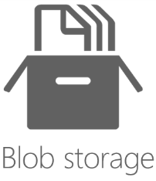

Windows Azure blob storage manages files that are physically stored at least three times in the datacenter where they live and optionally replicated to another datacenter in the same region (North America, Europe or Asia). The files are called binary large objects (blobs). The service is accessible thru REST APIs, which are also wrapped in client libraries for platforms and languages such as .NET, PHP, Java or Node.js to name a few of them.

## Hadoop

### Hadoop Framework and ecosystem

The Apache™ Hadoop™ project develops an open source framework that enables distributed storage and computing on inexpensive hardware to handle large volumes of data. At the core of Hadoop, there are two main components:

* Hadoop Distributed File System (HDFS™) stores and replicates blocks of data on the different computers that constitute a Hadoop cluster. The blocks are parts of files. This file system relies on the operating system (OS) file system. On Windows Server and Windows Azure, HDFS leverages NTFS on each and every node of the cluster.
* Hadoop Map Reduce is the framework that implements the Map Reduce algorithm. This algorithm enables highly distributed computing in two main phases based on the usage of keys and values. The map phase transforms key/value input into other key/value outputs. After an intermediary shuffle step has sorted the data by their new keys, the Reduce phase can consolidate the values that were calculated in the first place by the map phase. Several map/reduce jobs can be chained if necessary.

On top of these two components, a growing ecosystem of other components has been built by many contributors. The following picture illustrates a few of them.

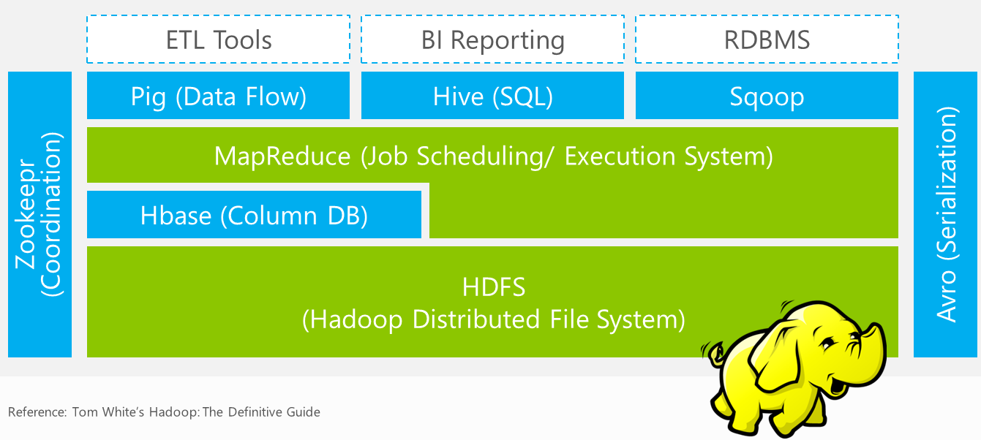

The components that will be used in this paper are as follows:

* HDFS is the distributed file system.
* Map Reduce is the batch job framework.
* PIG is a high level language (comparing to Map Reduce programming) that can describe jobs executions, and data flows. It also enables the execution of several jobs from one script.
* HIVE provides HiveQL, a SQL like language on top of Map Reduce. It is very popular because many people master SQL.
* SQOOP enables data exchange between relational databases and Hadoop clusters. The name starts like SQL and ends like HADOOP.

### Hadoop on Windows Server and Windows Azure

Microsoft is porting the Apache Hadoop Framework so that it can run in production on Windows Server and Windows Azure, without Cygwin, a collection of tools which provide a Linux look and feel environment for the Windows environment. This also includes additional components like an interactive console in JavaScript, and another one for HIVE that makes the cluster accessible thru a web interface besides the classic command line.

As previously mentioned, on Windows Server and Windows Azure, HDFS is implemented on top of NTFS. On Windows Azure, as a cluster would typically go away and be recreated for new jobs, it is also a good idea to have data stored in Windows Azure blob storage instead of HDFS, even if HDFS remains available. The main difference between the two is that HDFS data will go away when compute nodes are shut down and when the cluster is no longer needed to compute, while Windows Azure blob storage remains available.

For this reason, Hadoop on Windows Azure allows the usage of URI scheme ASV (/w the ASV protocol) to access blobs instead of using HDFS. ASV stands for Azure Storage Vault.

In the following picture, Windows Azure blob storage content is listed in container “books”, in the folder “fr-fr”. Then files are copied from Windows Azure blob storage to HDFS, and the HDFS folder is listed. Under the command line window, the storage account (deladonnee) content is seen thru CloudXplorer tool (a tool that can be downloaded from the Internet, which is built on top of Windows Azure blob storage API).

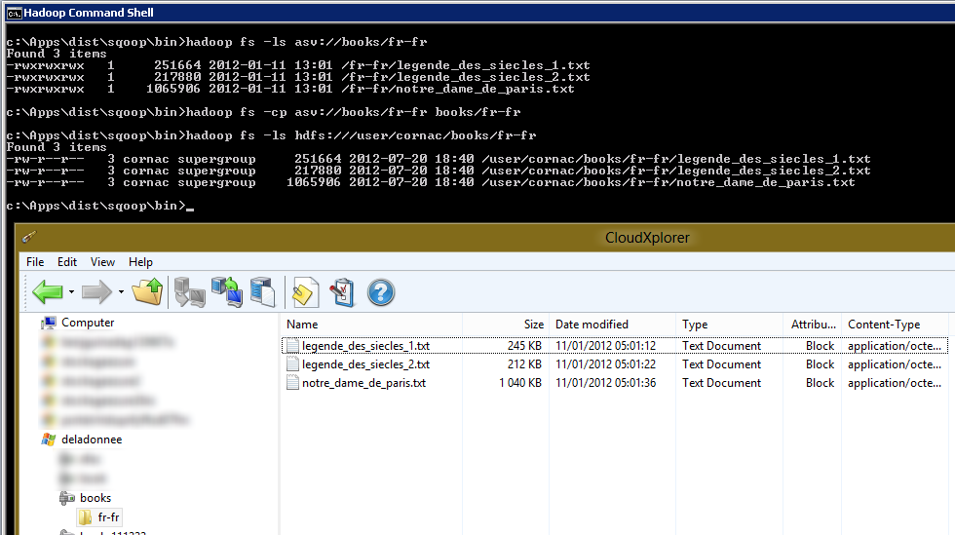

## SQL Server Integration Services (SSIS)

SQL Server is a set of tools that include an RDBMS system, a multidimensional OLAP and a tabular database engines, as well as other services like a broker service, a batch service (SQL Agent) to name a few. One of these additional components is an ETL tool called SQL Server Integration Services (SSIS).

The main goals of an ETL tool is to be able to import and export data to and from databases. This includes the ability to connect to external systems, but also to transform the data between the external systems and the databases. SSIS can be used to import data to and from SQL Server but also between external systems without requiring the data to go to or from SQL Server. For instance, SSIS can be used to move data from an FTP server to a local flat file.

SSIS also has a workflow engine to automate the different tasks (data flows, tasks executions, etc.) that need to be executed in an ETL job. An SSIS package execution can itself be one step that is part of an SQL Agent job, and SQL Agent can run different jobs.

An SSIS package has one control flow, and as many data flows as necessary. Data flow execution is dictated by the content of the control flow.



Control flow and data flow design is typically done by using the SSIS Designer. You can drop components from a toolbox to a surface.

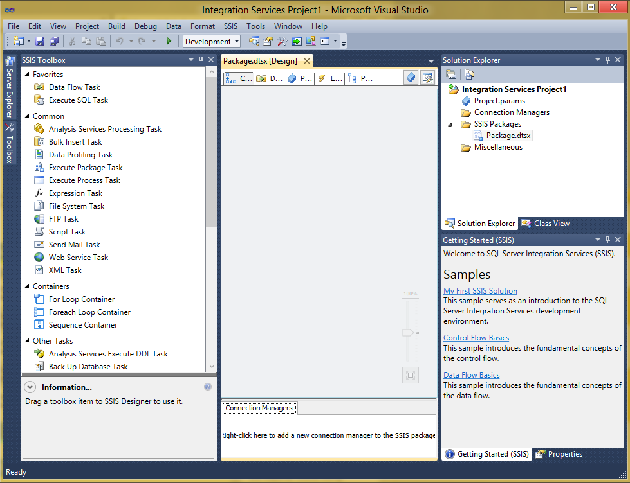

In SQL Server 2012, SSIS packages are developed in the Visual Studio 2010 shell where it can be run locally and debugged.

An SSIS package can also be generated from code. This enables scenarios where code generation is useful. An SSIS package is an XML file.

The following sections give additional details on what can be done in an SSIS package and how it can be used at runtime.

### Control flow

Inside a control flow, precedence constraints link tasks and specify conditions that determine whether the tasks run. A task can succeed or fail and there are three types of arrows to link two tasks:

1. Success (green arrow): The task that is downstream of another task is executed when, and only when the upstream task execution has succeeded.
2. Failure (red arrow): The task that is downstream of another task is executed when, and only when the upstream task execution has failed.
3. Completion (black arrow): The task that is downstream of another task is executed when, and only when the upstream task execution has completed (by succeeding or failing).

In the following picture, after T1 has succeeded, “After T1 success” and “After T1 completion” tasks are executed. Should T1 fail instead of succeeding, “After T1 completion” and “After T1 Failure” tasks are executed.

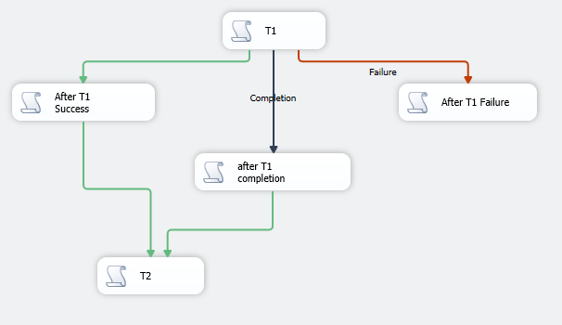

The control flow surface can accept the following components from the toolbox.

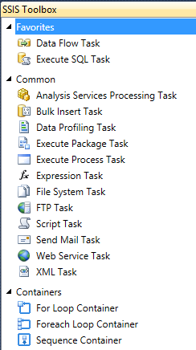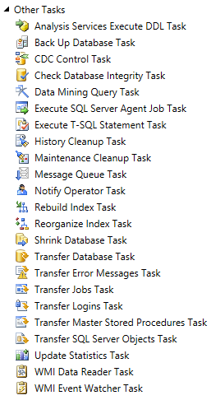

In particular, the Data Flow task runs a data flow.

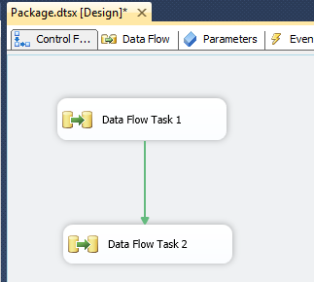

In the above example, there will be two data flow tasks available in the Data Flow tab:

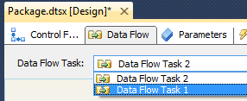

### Data Flow

A Data flow accepts a number of components from its toolbox:

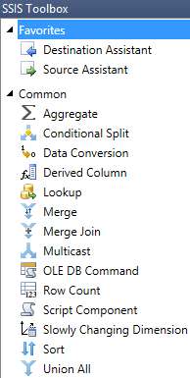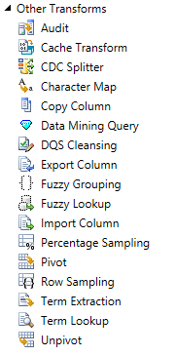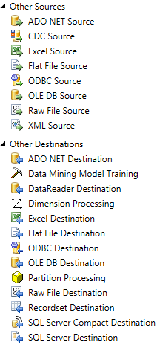

The toolbox contains data sources and destinations, as well as tools to transform data between the two. There are also components to manage the data flow such as “Union All” or “Conditional Split”.

### ODBC Data Flow Components

The Connector for Open Database Connectivity (ODBC) by Attunity has been introduced in SQL Server 2012 Integration Services (SSIS) which helps SSIS developers easily create packages that load and unload data from ODBC-supported databases.

The ODBC Connector is designed to achieve optimal performance when loading data into or unloading data from an ODBC-supported database in the context of SQL Server 2012 Integration Services (SSIS).

Both the ODBC source and ODBC destination enable high performance data integration with ODBC-enabled databases. Both components can be configured to work with row-wise parameter array bindings for high-functioning ODBC providers that support this mode of binding and single-row parameter bindings for low-functioning ODBC providers. You can connect the ODBC source to any destination or transform component supported by SSIS.

The documentation on MSDN library for those components is available at the following URLs:

* ODBC Source (*http://msdn.microsoft.com/en-us/library/hh758687.aspx*)
* ODBC Destination (*http://msdn.microsoft.com/en-us/library/hh758691.aspx*)
* ODBC Connection Manager (*http://msdn.microsoft.com/en-us/library/ms141665.aspx*)

As of this writing, the SSIS ODBC source and destination components are not compatible yet with HIVE ODBC, so the white paper samples do not leverage these components. Instead the samples use ADO.NET corresponding components that also enable ODBC connectivity.

### Extensibility

While the toolboxes contain a lot of components, it may be necessary to bring additional functionalities to SSIS. There is a SDK that enables you to create custom components. Also, the Script task and Script component that ship with SSIS accept code.

The Script task and the Script component use Microsoft Visual Studio Tools for Applications (VSTA) as the environment in which you write the scripts and the engine that runs those scripts. VSTA supports both the Microsoft Visual Basic and Microsoft Visual C# programming languages.

In SQL Server 2012, the Script task runs on top of the .NET Framework 4.0. Amongst many other examples, it is possible to call REST API from the Script task. Some RESTful web services come with an SDK for .NET languages that wrap the pure http web requests in a more easy way. It is possible to reference these DLLs in the Script task code.

It can also be necessary to develop components that connect to external data sources and destinations. The following code snippets come from the MSDN documentation. They show that developing a custom source component or a custom destination component uses streams; this enables the component to flow data of any size through SSIS.

[Developing a Custom Source Component](http://msdn.microsoft.com/en-us/library/ms136088.aspx)

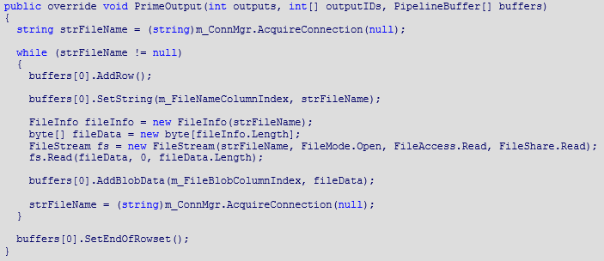

[Developing a Custom Destination Component](http://msdn.microsoft.com/en-us/library/ms135899.aspx)

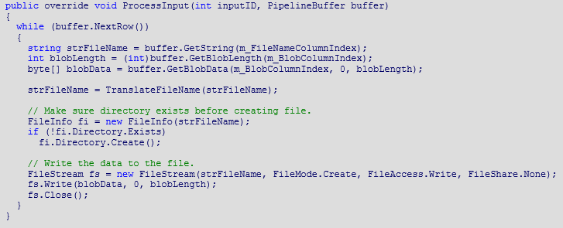

### Runtime

In production, the package is typically deployed to an SSIS catalog, which is a SQL Server database inside the SQL Server instance. The package can be referenced by one or more SQL Server Agent job steps. SQL Server Agent is a Windows Service that can be managed from within the SQL Server Management Studio tool. SQL Server Agent can schedule and run jobs. Each job is composed of one or more steps. A step can correspond to the execution of an SSIS package.

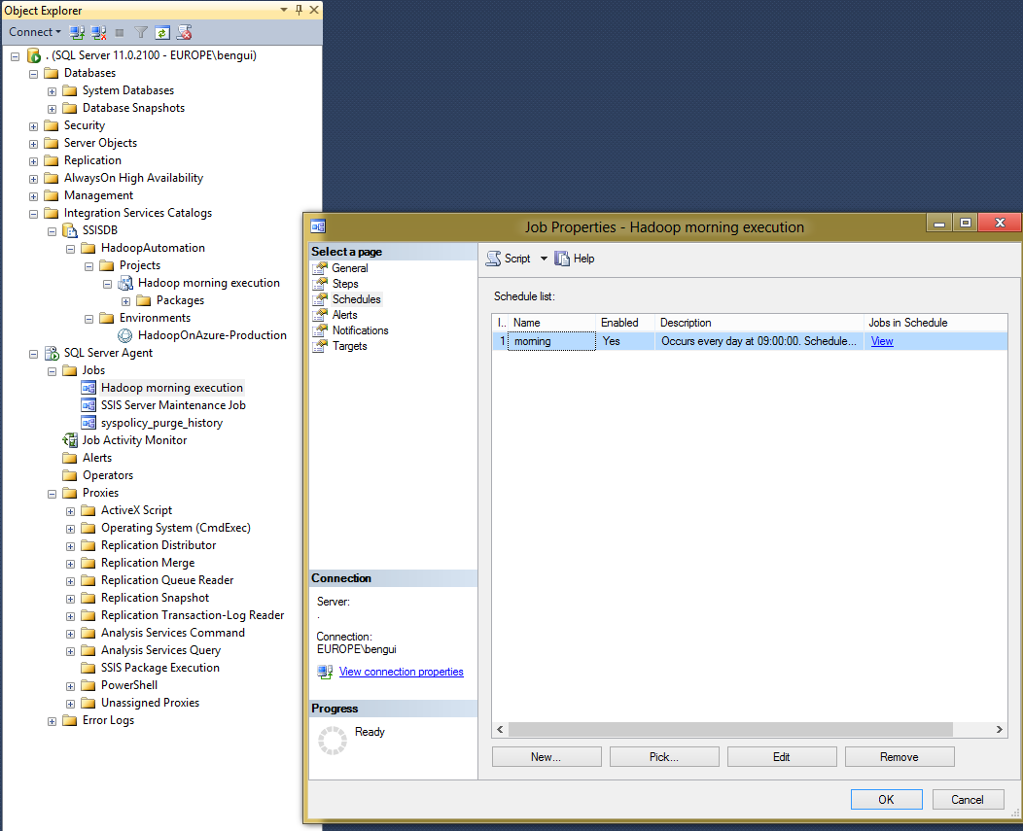

You can configure the job step to pass parameters to the SSIS package.

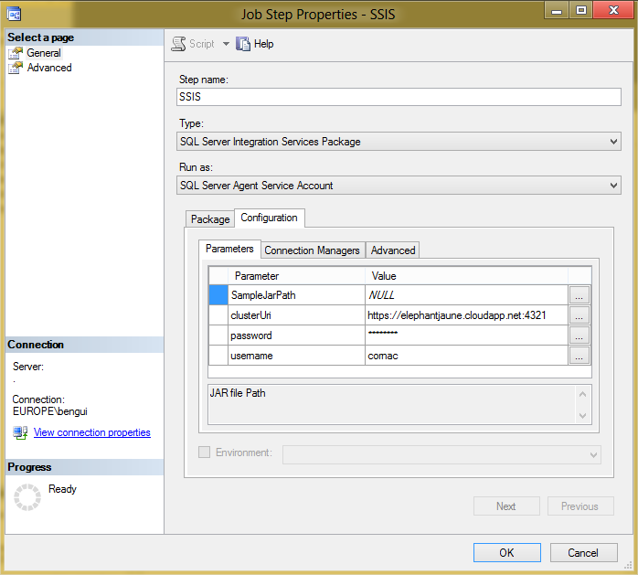

Note that SSIS packages using custom components are impacted by the SSIS installation runtime architecture. In development and production environments, custom components reference assemblies in both the Global Assembly Cache (GAC) and the SSIS folder. Typically, with SQL Server 2012 Integration Services, the SSIS folder changes depending on the runtime.

A SSIS 32-bit installation will indeed base its execution components on “C:\Program Files (x86)\Microsoft SQL Server\110\DTS” while a 64-bit will be based on its components on “C:\Program Files\Microsoft SQL Server\110\DTS”.

It is important to take this behavior into consideration when developing on a local machine and deploying to a production environment. It is also important to know that debugging on a 32-bit local machine and testing with 64-bit SSIS installed on the same machine requires deploying assemblies in both folders listed previously. A deployment in a production environment needs to reference assemblies in a single folder depending on the SSIS runtime installation.

If a custom component uses custom assemblies, these custom assemblies also need to be added to the SSIS sub-directory named “Binn”. This folder hosts external assemblies used by SSIS to execute the components correctly.

When debugging custom components with Visual Studio 2010, make sure your SSIS project is configured to run in 32-bit mode. Visual Studio 2010 only supports 32-bit runtime debugging for SSIS Projects. It cannot debug a component configured in 64-bit mode. In a development environment, set Run64BitRuntime to False in the project properties to ensure your project is running in 32-bit.

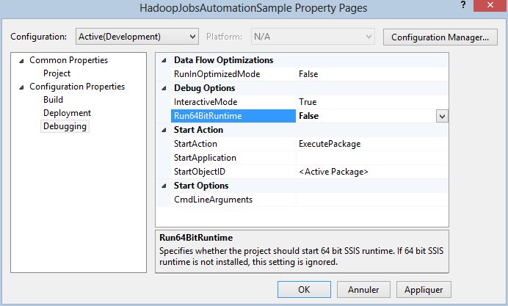

More information about “Building, Deploying, and Debugging Custom Objects” is available on MSDN (*http://msdn.microsoft.com/en-us/library/ms403356*).

# Scenarios and Motivation

## Automate job executions and transfers

From a technical perspective, and as described in the preceding chapter, SSIS is an automation tool and a data transfer tool that includes transformation capabilities. Automation can be authored in a graphical way, which makes it easier to document how tasks are chained. SSIS packages are executed in batch.

Hadoop typically executes batches against large amounts of data that come from a number of sources, and stores results in Hadoop storage and also possibly exported to BI. Thus, it makes sense to orchestrate batch jobs that span BI and Hadoop from SSIS.

The following picture shows an SSIS control flow where a Hadoop cluster on Windows Azure is dynamically provisioned while data are added to Windows Azure blob storage. Then a few jobs are run in the Hadoop cluster. If everything runs well, resulting data is exported to BI. After the execution of this, the Hadoop cluster on Windows Azure is released and the SSAS data is updated (processed).

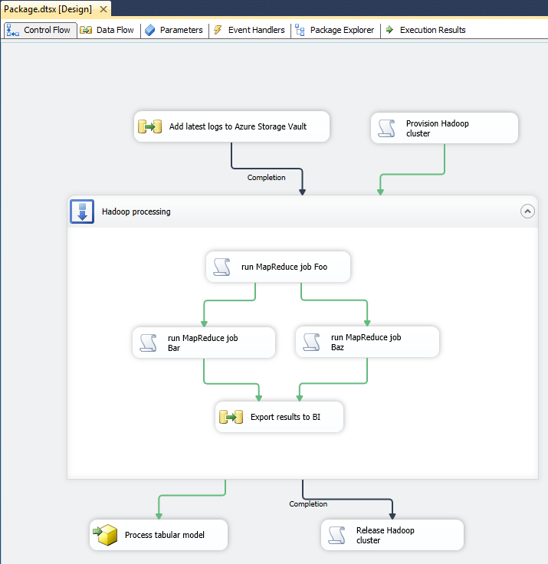

## Commerce Web Site Performance analysis

From a functional perspective, Big Data tools like Hadoop make it possible to gather more data in order to gain more insights. In a traditional e-commerce data flow, most of the unstructured data is trashed, and only data that can be processed immediately is kept.

[Traditional](http://msdn.microsoft.com/en-us/library/ms136088.aspx) e-commerce data flow

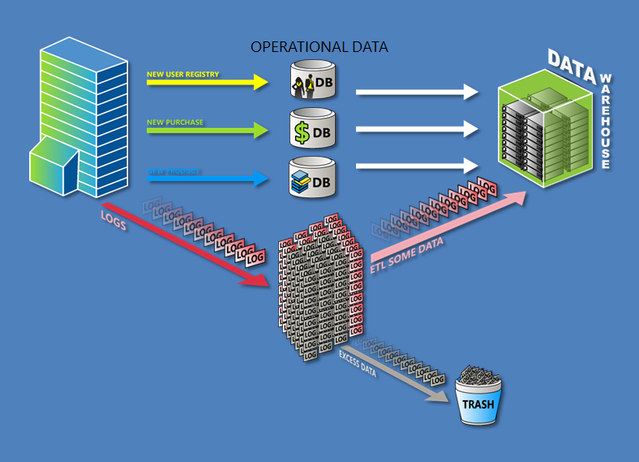

With tools like Hadoop, all unstructured data can be stored. The part that is interesting today is processed and included in the data warehouse. This is done thru a batch that typically involves an ETL tool. As part of this batch, it may also be possible to run additional exploratory batches against the data that is kept into Hadoop.

New exploratory e-commerce data flow

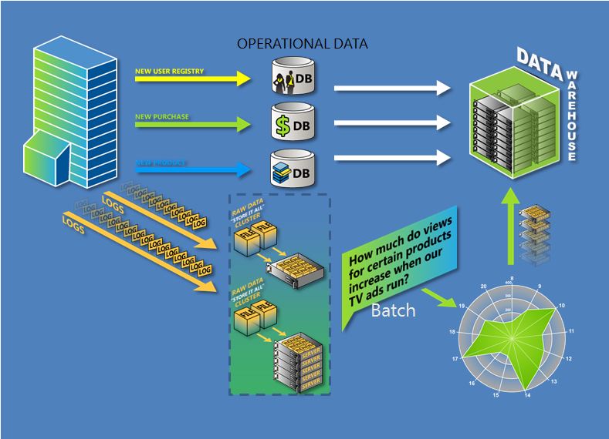

Using this principle, an ecommerce website wants to analyze their website performance. Performance can be from a technical perspective, a sales perspective, or other types of performance.

They need to aggregate data from a number of sources and add this data on a daily basis.



Some data sources keep their data for a limited period of time (like 3 months).

Route cause analysis may require going back in time and exploring failures during the last 2 or 3 years. This could be done by a query ran by Hadoop against its Hadoop storage.

As SSIS is already used to transfer data to and from Hadoop, it may also be used to create a workflow that waits for Hadoop tasks to be executed before other Hadoop tasks or BI jobs are executed.

The BI platform will typically contain only part of the whole data. Selection is in terms of the number of fields available, the time frame, and the level of details (the BI platform will have aggregated data while the Hadoop platform could keep detailed information).

## Simplified scenario

In this white paper, a simplified typical scenario will be used with sample code.



In this simplified scenario, only IIS logs are captured. They are pushed to Hadoop storage (Windows Azure blob storage in the case of a Hadoop on Azure cluster). The logs can then be analyzed through HIVE which makes them available through a SQL query language[2]. The result of that job can then be pushed to SQL Server relational database tables. In the case of SQL Server on premises and Hadoop on Azure, we would typically leverage the HIVE ODBC driver to transfer the data through an SSIS data flow.

## Other scenarios

An ecommerce website is an example of how SSIS and Hadoop can be used together, but there are many other possible scenarios that can be envisaged.

In fact, each time Hadoop is used with the SQL Server platform, using SSIS also makes sense. In a more general way, Microsoft’s approach to Big Data is the following one. It goes from data management to insight through data enrichment.



In this vision, the BI platform and Hadoop play complementary roles and SSIS sits between the two.

# Automation

This chapter is about the automation of jobs and data flow with Hadoop from an SSIS package. After describing what needs to be automated, we’ll see how to automate from a Hadoop perspective and then from an SSIS perspective, and eventually we’ll see how to join the two. There are also job automations capabilities in Hadoop, and this chapter will also cover how this fits in the SSIS automation story.

## What needs to be automated

While using SSIS with Hadoop, following main tasks need to be automated:

* Provisioning /releasing a Hadoop cluster: Note that this is useful only for a transient cluster in Hadoop on Windows Azure, or Hadoop on a private cloud on Windows Server.
* Starting job: This corresponds to starting a job and getting an ID that will enable waiting for that job to finish.
* Waiting for a job to finish: Once a job has been started, it must be monitored from SSIS so that other tasks can be started depending on the success or failure of the job.
* Transfers: It is also necessary to automate data transfers before, in parallel or after other tasks. In SSIS, data transfers occur in the data flow tasks that are in the control flow, so this kind of automation is part of the SSIS automated workflow.

## How to automate Hadoop actions

### Provision / release a cluster

Windows Azure can be automated through Windows PowerShell via a set of cmdlets:

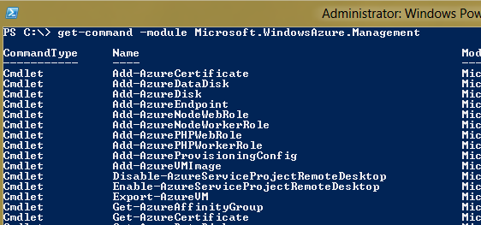

It is also possible to automate Windows Azure management through another command line tool in Node.js that is intended to be used mainly from Linux and Mac client machines. REST APIs, are also available through the SDK that can be used from languages such as .NET Framework languages or PHP.

As SSIS can run on Windows Server, Windows PowerShell is the tool of choice to automate management tasks.

In the case of a private cloud, it is typically part of the private cloud building project to provide Windows PowerShell cmdlets too.

During the Hadoop on Azure developer preview[3], it is not possible to automate Hadoop clusters. At launch time, Hadoop will be a service like others in Windows Azure, so it should inherit from Windows Azure automation.

So, while it is not available today, it is assumed that provisioning and releasing a transient Hadoop cluster will eventually be available through Windows PowerShell cmdlets.

### Start and monitor a job

Hadoop on Windows Server and Windows Azure provides a REST API in order to launch and monitor jobs running inside the cluster. Sample code that uses this REST API is available on GitHub[4]. This allows starting and monitoring jobs like the Hadoop on Azure and Hadoop on Windows Server interactive JavaScript console does.

The sample code contains a C# console that runs a few jobs and waits for them to finish before starting a next job. The API can start several jobs in parallel and then wait for the jobs to finish. Each started job has an ID which is then used to monitor job completion.

Also, a good way to run job on a Hadoop cluster consists in using the newly released Windows PowerShell cmdlets via the client SDK[5].

To install the client SDK, see “How to Install the PowerShell cmdlets for Apache™ Hadoop™-based Services for Windows” (*http://blogs.msdn.com/b/cindygross/archive/2012/08/23/how-to-install-the-powershell-cmdlets-for-apache-hadoop-based-services-for-windows.aspx*).

This provides you with the following cmdlets:  
  
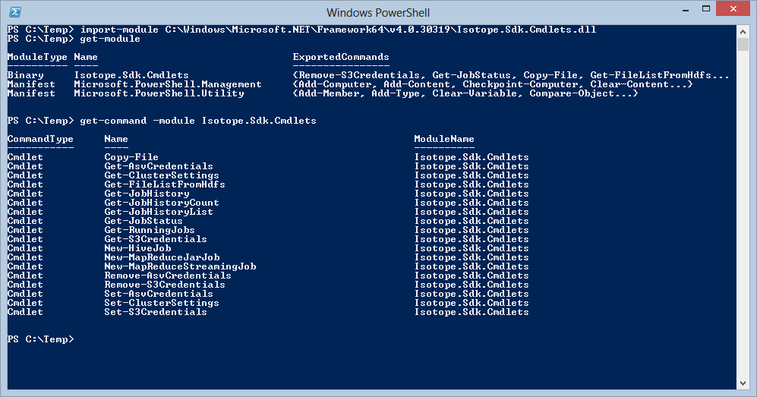

## How to automate from SSIS

### Tasks

In an SSIS package, the control flow can be filled with tasks. Most of the tasks are related to SQL Server, but not all of them. It is perfectly legitimate to use SSIS to automate jobs and data transfer that do not start, pass through or end in a SQL Server database.

#### Execute C# code with the script task

On SQL Server 2012, by default the Script task runs .NET Framework 4.0 C# code.

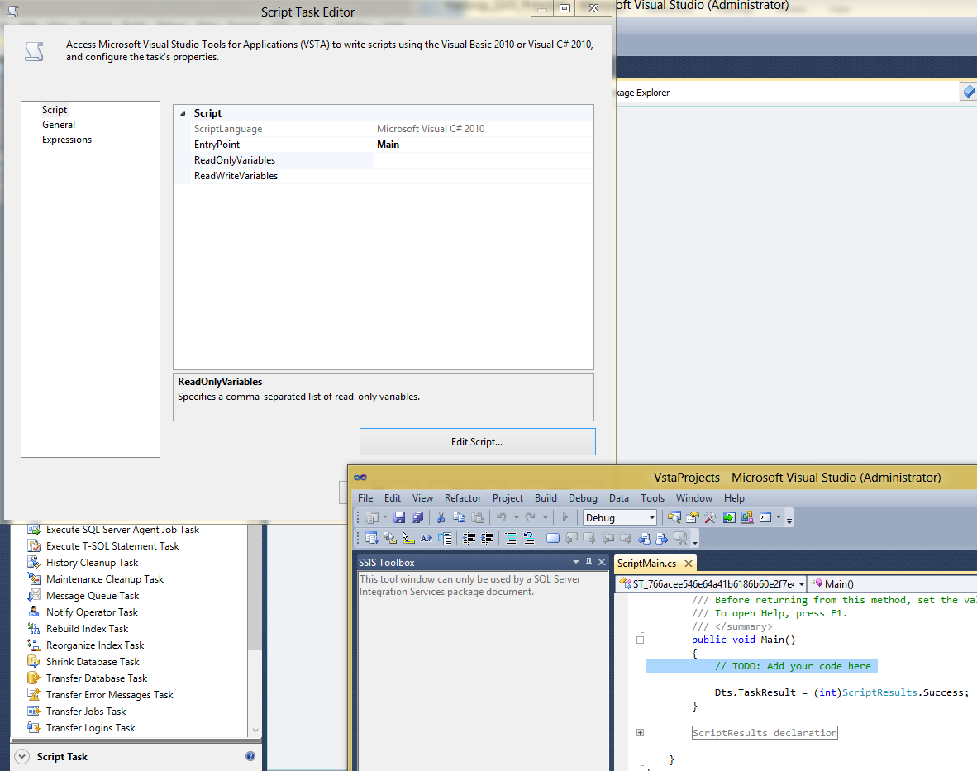

This code can reference external libraries. For proper deployment in production, those assemblies must have a strong name and they must be deployed to the Global Assembly Cache (GAC)[6]. These external libraries can typically be part of an SDK to connect to an external REST API for instance.

#### Execute Windows PowerShell scripts

SSIS has the ability to call batch files. This is done with the Execute Process task. There is no direct support to directly call PowerShell scripts but this can be achieved with little effort.

Edit a new Execute process task:



In the process section, enter “%windir%\System32\WindowsPowerShell\v1.0\powershell.exe” as the value for the Executable property.

Note that even if the path contains v1.0, this still contains the latest and only current version of Windows PowerShell on current Windows (ex: v3.0 in Windows 8 and Windows Server 2012)[7].

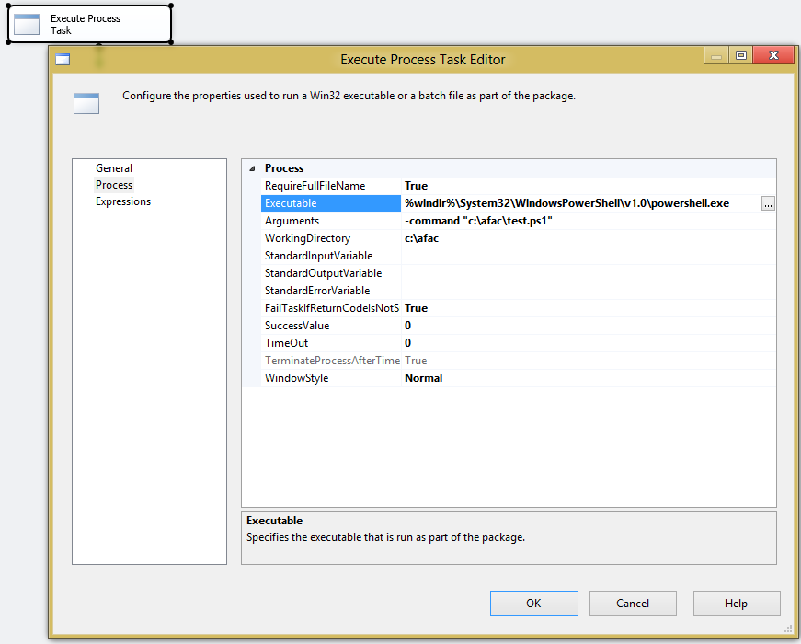

In arguments, enter “-command <your ps1 script path>”. You may also want to provide the working directory.

Instead of a .ps1 file, it is also possible to have a simple command that calls a cmdlet.

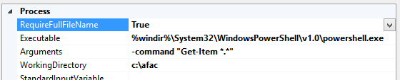

## Automating Hadoop actions from SSIS

This section has an example that shows how to put it all together.

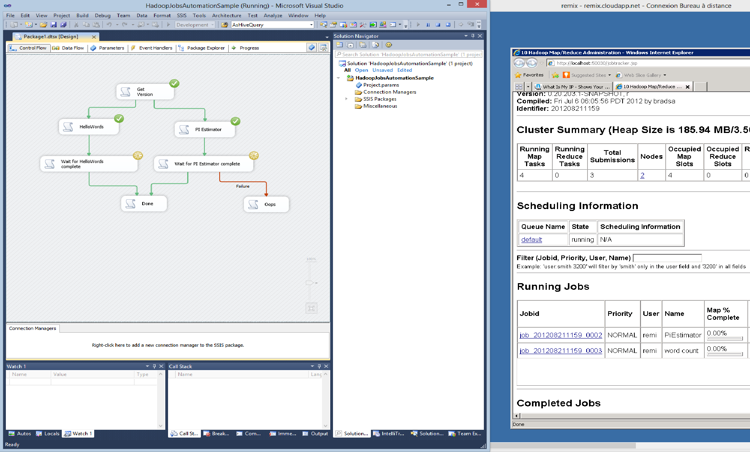

In the above picture, SSIS is running two jobs and is waiting for their completion. On the right, by remoting on the Hadoop cluster, jobs appear with the running state in the Hadoop Map/Reduce Console.

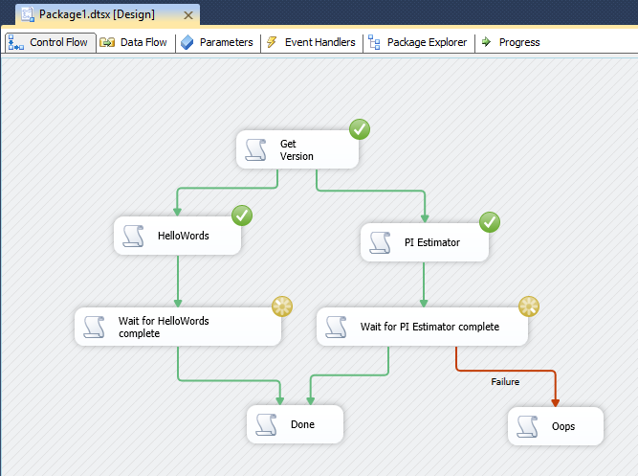

The above picture shows the control flow while executing the SSIS package in debug mode, while the two Hadoop jobs are executing.

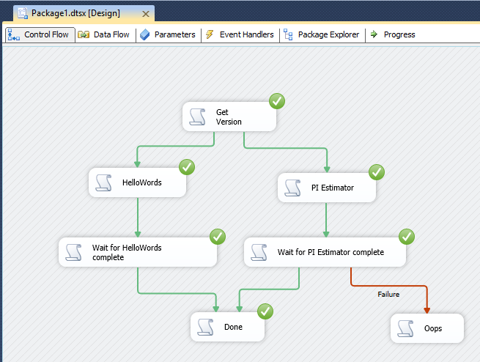

The above picture is the same as before, later on, when the two Hadoop jobs are completed, and succeeded.

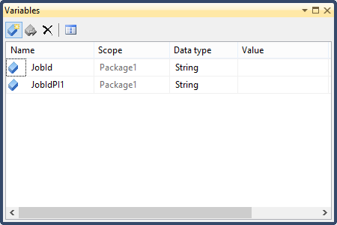

The two user variables above are used to store job IDs returned by the Hadoop cluster for the jobs. Each variable can then be used by other SSIS tasks to wait for the right job to finish.

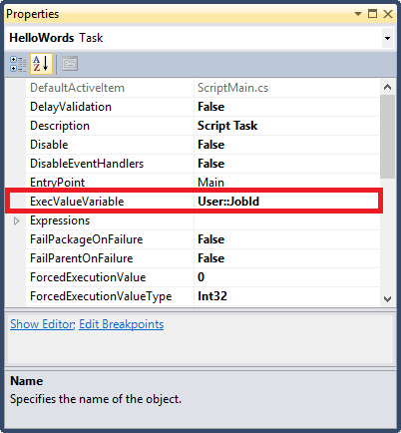

Binding the ExecValueVariable property of the HelloWords task to the JobId variable will allow the “Wait for HelloWords Complete” task to monitor the progress of the Hadoop job.

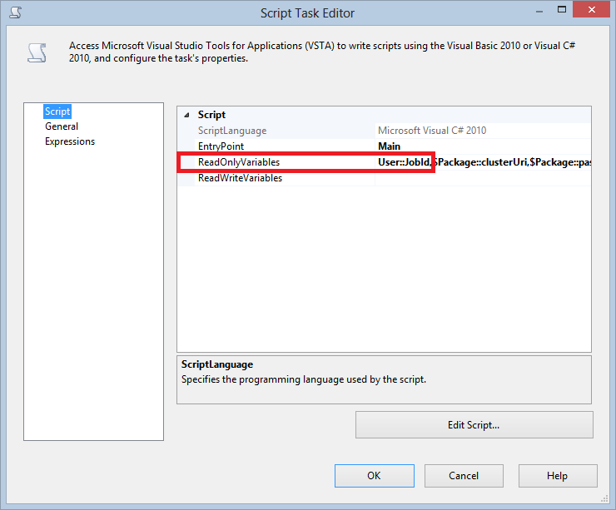

The “Wait forHelloWords complete” task is configured to receive the JobId variable set by the “HelloWords” task.

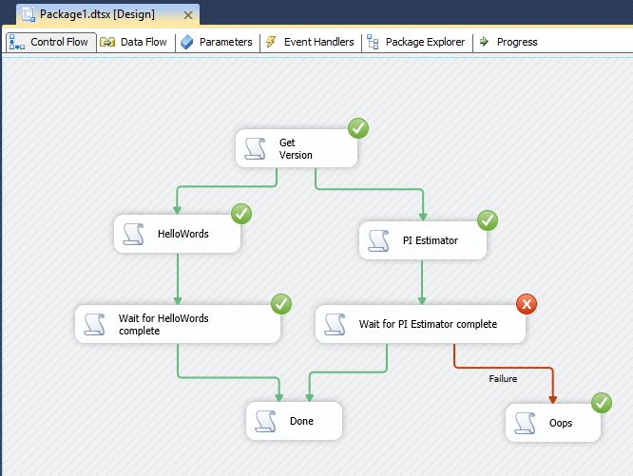

In the above picture, note that the “Done” task is not executed in so far as there is a success dependency (green arrow) with an upstream task and the upstream task did not succeed.

The source code for each Script Task is provided with this whitepaper in the sample code “SSIS Packages Sample for Hadoop and Windows Azure” (*http://code.msdn.microsoft.com/SSIS-Packages-Sample-for-2ffd9c32*) on the MSDN Samples Gallery.

## How to combine with Hadoop ecosystem automation means?

As already noted, the Hadoop ecosystem is growing quickly, and there are Hadoop ways of automating things. For instance, a PIG job can also be seen as a sequence of map/reduce jobs. More specifically, Oozie was designed to automate jobs execution inside a Hadoop cluster.

When using SSIS to automate, it might be a good idea to delegate more specific workflows running exclusively in the Hadoop world to more specialized frameworks.

### PIG

Apache PIG™ is a platform for expressing high level data flow. It allows through Pig Latin, the high level PIG language, to execute a sequence of map/reduce jobs that can be monitored by Hadoop.

As of writing, there are no wrappers to call a PIG script in SSIS. However, the Windows Server REST API for Hadoop is able to send Hive queries by uploading a file, containing the query, to Hadoop. Then a command is executed calling Hive with the uploaded file as parameter.

To use PIG with SSIS, inspired by the HIVE example above, a high layer library has been developed over the Hadoop REST API Library in order to support PIG scripts and an ease of use for users. The workflow remains the same as a Hive query running with the REST API but calling PIG instead of Hive and defining a specific variable. The library and source code are provided with the white paper.

The sample, provided with this white paper in the sample code “SSIS Packages Sample for Hadoop and Windows Azure” (*http://code.msdn.microsoft.com/SSIS-Packages-Sample-for-2ffd9c32*) on the MSDN Samples Gallery, focuses on running a PIG script through SSIS along with Script tasks.

Using C# via Script tasks allows running PIG commands and waiting for completion thanks to the library described above. This solution allows better control, advanced tracing and more complex scenarios.

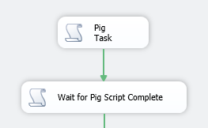

Pig Task source code

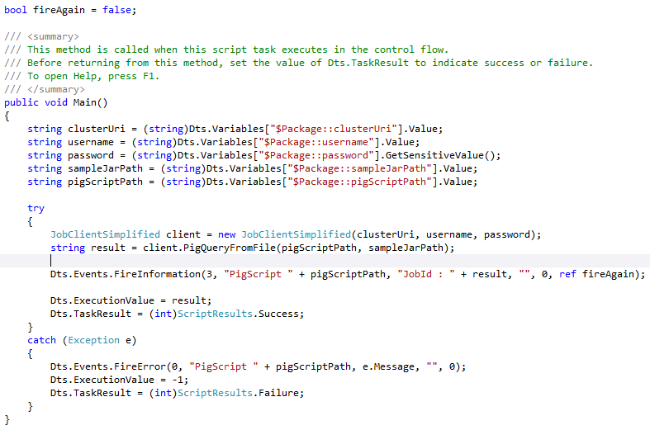

In this sample, we run a PIG query with a file script. The file script is dependent on a jar file to process the request correctly so we upload it to Hadoop by specifying its path.

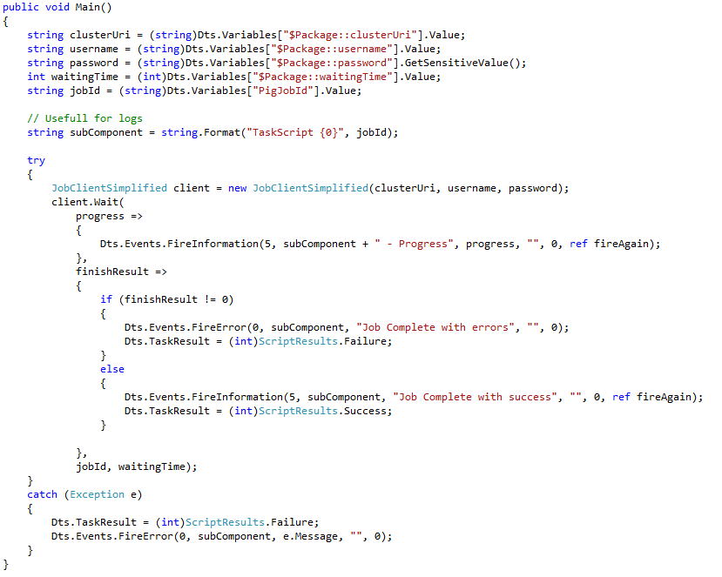

Finally, we use another script task (“Wait for Pig Script Complete*”*) in order to subscribe to the progress event to log details in SSIS and to wait for the job completion.

### Oozie

Apache Oozie™ is a workflow scheduler for Hadoop that also implements what we use SSIS for in this paper[8]. As of writing, Oozie has not been ported to Windows.

Oozie can automate different kinds of Hadoop jobs like SQOOP jobs, Map/Reduce jobs, or PIG jobs.

### When to use SSIS?

Hadoop has its own means to automate jobs. So is it useful to use SSIS to automate jobs from outside a Hadoop cluster?

SSIS has the advantage of having a graphical (as well as an XML) representation of the workflow, which is not currently the case of both Oozie and PIG.

On the other hand, PIG and Oozie are more standard ways of executing a number of jobs in Hadoop.

Interestingly enough, they all can be combined in order to take the best of all worlds.

SSIS is very well suited to coordinating jobs that run in Hadoop with jobs that run outside Hadoop. A job running in Hadoop can be the execution of an Oozie workflow job or a PIG script. The Oozie workflow or PIG script is a sub-workflow of the main workflow in SSIS.



# Transfer Data

In this chapter, we’ll see how to transfer data from Hadoop or to Hadoop with SSIS. This includes streams that traverse SSIS, and also jobs that are executing direct transfers between Hadoop and the external source or destination. All of this is further explained in the synopsis section. Then considerations regarding Hadoop location and storage, as well as data structure are detailed. These considerations are important while listing the transfer mechanisms to and from Hadoop. The chapter ends with a list of mechanisms to use in the different cases.

## Synopsis

SSIS can be used for two types of data transfer:

1. SSIS issues a command that will start data transfer (Control Flow),
2. Data stream goes through SSIS (Data Flow).

Whenever possible, data streams constitute a better option in so far as they offer more possibilities:

* Transformations like data cleansing, filtering, fuzzy lookup, etc.
* Connectivity: the Hadoop cluster needs connectivity to SSIS, not to the actual source or destination.
* No need to generate intermediate files to solve connectivity issues, which may lead to better overall performance.

The data transfers will happen in one way or another, as shown in the following image.



In the picture, Hadoop storage can be HDFS (of course!) but also Windows Azure blob storage (Azure Storage Vault, ASV). Hadoop storage can be used from Hadoop jobs (map reduce, HIVE, PIG, etc.).

The Apache Hadoop Framework also includes other URI schemes like S3 and S3N for Amazon Web Services S3 storage. However, they are not considered as Hadoop storage in the scope of this paper. It would not be efficient (for technical and economic reasons) to have a Hadoop cluster on Windows Server[9] or Windows Azure running jobs against S3 data. Thus, in the picture, S3 is considered a data source or a data destination.

Also note in the picture that SSIS and the Hadoop cluster can be on the same LAN or they can be separated by Internet.

## Hadoop cluster and data characteristics

### Hadoop on premises, Hadoop in the cloud

Depending on where the Hadoop cluster is, it would be better for Hadoop data to reside in HDFS or cloud storage (ASV).

* For a permanent on premises cluster, data would live in HDFS.
* For a transient cluster hosted in a private cloud, data would be copied between NTFS and HDFS, HDFS being the working file system, and NTFS being the permanent storage file system.
* For a transient cluster in Windows Azure, data would preferably live in Windows Azure blob storage.
* For a permanent Hadoop cluster in the cloud, it could be in HDFS or in cloud storage depending on additional considerations like the size of the cluster, costs, etc.

Here are additional details on HDFS, ASV, and NTFS.

Cloud storage can be used instead of HDFS. For instance, on Hadoop on Azure, one can use asv://<some Windows Azure blob storage path> instead of hdfs://<some HDFS path> and that will work the same way. This is why the synopsis schema shows HDFS and also ASV as Hadoop storage.

In a transient Hadoop on Windows Azure cluster, ASV is the preferred storage.

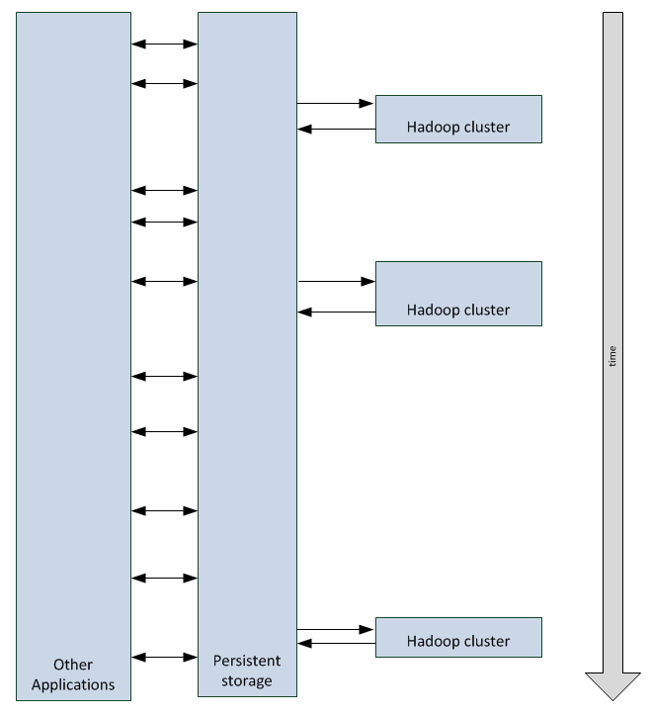

The above picture shows a cluster that is created three times over time while data is still available in ASV persistent storage.

Still it is possible to copy between HDFS and cloud storage with the “hadoop distcp” command. This is a standard distributed map job that copies blocks of data in parallel from the data nodes themselves.

Data can also be copied to and from local file system

hadoop fs -CopyFromLocal

And

hadoop fs –CopyToLocal

The Local file system could be any file that can is accessible through LAN by the head node. UNC syntax is not supported, but having a network drive is a perfect and easy workaround[10].

As a consequence, in the case where the Hadoop cluster and the data source or data destination are in the same LAN, this can be a way to move data to and from HDFS.

### Unstructured, tabular, and compressed data

Data could be grouped in the following categories:

* Tabular data is structured as rows, with all rows having the same predefined list of columns. This corresponds to data that can be stored in a relational database table or exposed thru a HIVE table in Hadoop.
* Unstructured data corresponds to all other cases:
  + Lines of text: The data can be divided into rows of text. The structure of each line can be managed by a Hadoop job.
  + Binary data: The whole data is a single binary object, such as an image (.png, .jpg) or a video. This could include compressed files. Compression is a topic covered below.

Some Hadoop mechanisms (like SQOOP and HIVE) can run only on tabular data.

For example, tabular data can be stored as text files in a folder. All the text files have the same structure. The folder can be exposed as one HIVE external[11] table.

The principle of SSIS is to manage records, so tabular data is the best fit for the tool. For unstructured lines of text, SSIS would transfer the data as one column rows. For unstructured binary data, SSIS could transfer the data as one row of one column. This is important only when transferring data through SSIS. It is not important when data is transferred by executing a script or Hadoop job that goes directly from the data source to Hadoop storage or from Hadoop storage to the data destination.

Hadoop often uses text files that are very good candidates for compression because the ratios are quite high. Still, compression also comes with drawbacks. In particular, Hadoop files typically need to be split before being stored as HDFS blocks and processed by map reduce algorithms. Hadoop uses a number of compression formats like DEFLATE, gzip, bzip2, or LZO and there are several strategies around their respective use which are beyond the scope of this paper. Also, in most cases, SSIS may be used to upload deltas (ex: only the logs of the day) to Hadoop cluster; this makes volumes handled by SSIS smaller than the whole amount of data managed by the cluster itself.

So, compression is not always the best option. Still, there are cases where it is important to be able to upload or download compressed files.

The compression and decompression software one uses may be packaged as a library or as an executable file.

In the case of an executable file, SSIS can generate an uncompressed file locally, run a control flow task that calls the executable to generate a compressed file, then upload that compressed file to the Hadoop cluster. On the other way, SSIS can download the compressed file, and then run a control flow task that decompresses it to another local file before managing the uncompressed file.

In the case of a .NET compatible library, components like the sample Azure Blob Storage destination and Azure Blob Storage source components that are provided together with this white paper could be modified to leverage such libraries. Important points while writing such code include:

* The sample Azure Blob Storage destination provided with this white paper receives lines of data, writes them to ASV blocs that eventually make a block blob. It could be changed to receive lines of data, pass that data (optionally via a memory stream) to the compression algorithm which would generate a stream that could be uploaded to ASV through the UploadFromStream method (*http://msdn.microsoft.com/en-us/library/microsoft.windowsazure.storageclient.cloudblob.uploadfromstream.aspx*).  
  Written in another way, that would look like this: receive data lines from SSIS [🡺 write to a memory stream] 🡺 compress to a compressed stream 🡺 UploadFromStream (to ASV)
* Similarly, the Azure Blob Storage source component would be adapted and leverage the DownloadToStream method (*http://msdn.microsoft.com/en-us/library/microsoft.windowsazure.storageclient.cloudblob.downloadtostream.aspx*).
* It may also be interesting to produce several compressed files instead of one, each file being smaller that the size of a HDFS block. On the reverse way, assembling such blocks in a unique stream would also be necessary.

## Transfer mechanisms

In this section, for each possible transfer mechanism, we’ll consider the constraints, and see how to integrate with SSIS from a data flow and from an automation perspective.

### HIVE ODBC

Microsoft adapted an ODBC driver that links HIVE to Excel (With Excel add-in). The driver can also be used from SSIS and other ODBC clients on Windows.

#### Moving data to Hadoop

Hive ODBC is not a valid option to upload to Hadoop.

The reason is that HIVE itself does not allow INSERTs to a hive table because HIVE can only load data (by overwriting a whole table) from a HIVE query (INSERT OVERWRITE) or from a local or HDFS file (LOAD DATA).

There is no equivalent in HIVE to the standard SQL INSERT statement

INSERT INTO myTable values (x, y)

So there is no way to upload to HIVE from an SSIS data stream.

#### Moving data from Hadoop

HIVE ODBC is a perfect way to move data from a HIVE table to outside of Hadoop.

HIVE tables can be stored in HIVE format with specific Serializer/Deserializer (SerDe). They can also be stored as external tables. In the latter case, HIVE has metadata that describe the tabular structure of text files in a Hadoop storage folder.

Hadoop on Azure exposes a TCP port that can be manually opened to expose the ODBC endpoint on the Internet. Hadoop cluster credentials are required to access that endpoint.

A sample of that type of transfer is described in the blog post “HADOOP, HIVE, ODBC, SSIS, SQL Azure, SQL Azure Reporting” (*http://blogs.msdn.com/b/benjguin/archive/2012/03/07/hadoop-hive-odbc-ssis-sql-azure-sql-azure-reporting.aspx*).

A copy of that blog post[12] is available in the appendix.

With HIVE ODBC, automation is provided by the SSIS data flow that is part of the control flow.

### HDFS Streaming

There are different current and future ways of streaming data to and from the Hadoop distributed file system (HDFS). They are described in this section.

For HDFS streaming, automation is provided by the SSIS data flow that is part of the control flow.

#### FTPS

In the current version of Hadoop on Windows, FTPS[13] is the main way to stream data to and from HDFS. The documentation[14] is available as examples that can be found here:

* “How to SFTP Data to Hadoop-based services on Windows Azure” (*http://social.technet.microsoft.com/wiki/contents/articles/6779.how-to-sftp-data-to-hadoop-based-services-on-windows-azure.aspx*),
* “How to FTP data to Hadoop-based services on Windows Azure” (*http://social.technet.microsoft.com/wiki/contents/articles/6229.how-to-ftp-data-to-hadoop-based-services-on-windows-azure.aspx*).

The samples use the command line utility “curl” which works perfectly well in that scenario.

SSIS has an FTP task that can be used in a control flow, but it is FTP only. Hadoop on Windows is FTPS only, so there is no match in terms of protocols. That’s why the best way to automate FTPS transfers to/from Hadoop on Windows is by running command lines, using the Execute Process task, that leverage “curl”.

The general principle for HDFS streaming would be to use the SSIS data flow rather than the SSIS control flow. In the case of FTPS, and in the current preview implementation of Hadoop on Windows, we could not have FTPS working with clients other than “curl”. In particular, we tested the FTPS library available on the CodePlex forge: “Alex FTPS Client” (*http://ftps.codeplex.com/*)[15].

As a workaround, the data flow should be in two parts, and use local temporary files. This may incur performance penalties and require local storage in the case of big amounts of data. For moderate incremental files, this should not be an issue.

To transfer data to Hadoop, the workaround would look like this in the control flow:

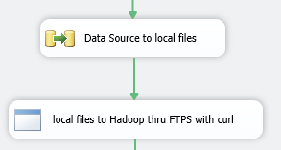

Similarly, to transfer data from Hadoop, the workaround would look like this:

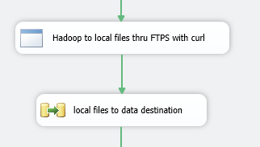

#### Windows HDFS Managed (WinHdfsManaged)

A library named Windows HDFS Managed enables accessing HDFS from a .NET Framework language like C#. Carl Nolan on his blog has documented its use. See the blog post “Hadoop .Net HDFS File Access – Revisited” (*http://blogs.msdn.com/b/carlnol/archive/2012/06/02/hadoop-net-hdfs-file-access.aspx*).

On a Hadoop on Azure cluster, the library is available on the head node in the C:\Apps\dist\contrib\WinLibHdfs folder:

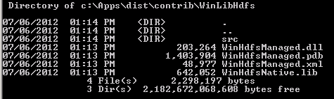

The .NET Framework app connecting to HDFS (using a command line app called by SSIS, or a script task in C# running from within the SSIS package) connects to the Hadoop cluster through the TCP port 9000. A Hadoop on Azure cluster does not expose this port publically has it is the HDFS name node service itself. Thus, Windows HDFS Managed library can be used with LAN connectivity only.

To connect to HDFS through SSIS, the Windows HDFS Managed library needs to be signed and built for both 32-bit and 64-bit environments. This specificity enables the Visual Studio design-time tool (32-bit) to create packages and to run these packages on SSIS (64-bit).

To sign the Windows HDFS Managed library, set the Delay Sign option in Visual Studio 2010 to Yes. This option adds the “/DELAYSIGN” argument during compilation to specify that the assembly could be signed later. Secondly, specify a key pair file[16] in the Key File property. This key pair file is the one that will be used to sign the assembly.

These steps for partially signing the assembly let you use the Strong Name tool (sn.exe) utility to sign an assembly with a key pair.

Command line to generate a key pair file:

sn –k keypair.snk

Sign an assembly with a key pair file:

sn –R assemblyToSign keypair.snk

For more information about signing an assembly, see article on MSDN (*http://msdn.microsoft.com/en-us/library/xc31ft41.aspx*).

In addition, the signed Windows HDFS Managed library has to be deployed in the GAC (Global Assembly Cache) and in the SSIS reference folder to allow both SSIS and Visual Studio to see it and to enable custom HDFS components to reference the assembly.

Once again, remember that SSIS packages with custom HDFS components have to be created in the same LAN as the Hadoop cluster. This constraint is due to the Windows HDFS Managed library, which can be used with LAN connectivity only.

#### Other HDFS streaming mechanisms

The Hadoop framework ecosystem is expanding rapidly, with new projects that may also be used to push or pull data to and from HDFS.

##### WebHDFS

WebHDFS is a REST API that can read and write HDFS files and folders.

WebHDFS is described on a blog post by HortonWorks: “WebHDFS – HTTP REST Access to HDFS” (*http://hortonworks.com/blog/webhdfs-%E2%80%93-http-rest-access-to-hdfs/*).

The full documentation, by Apache, is available on the “WebHDFS REST API” page (*http://hadoop.apache.org/common/docs/stable/webhdfs.html*).

Since its authentication mechanism is Kerberos, use WebHDFS on a LAN rather than on the Internet.

##### Flume

The goal of Flume is to collect logs from a number of sources toward HDFS storage.

The blog post “Apache Flume - Architecture of Flume NG” (*https://blogs.apache.org/flume/entry/flume_ng_architecture*) may be a good entry point for that project, which is still incubating.

Flume may be a good option in future releases to push logs to HDFS. This is something to monitor.

### Windows Azure Blob Storage API

These APIs enable download from blob storage and upload to blob storage. When using Windows Azure Blob Storage (ASV) API, Automation is provided by the SSIS data flow which is part of the control flow.

The main API is a REST API and it is documented on MSDN[17]. But, there is also a managed library that wraps the REST API and makes it much simpler to use ASV from C#[18].

The Windows Azure reference website at *www.windowsazure.com* provides a good entry point to understand how to use the ASV API, notably on the page “How to use the Windows Azure Blob Storage Service in .NET” (*http://www.windowsazure.com/en-us/develop/net/how-to-guides/blob-storage/*).

With SSIS, as the managed library API provides streaming capabilities, it is possible to push data from SSIS to ASV by developing a Custom Destination Component; see article on MSDN (*http://msdn.microsoft.com/en-us/library/ms135899.aspx*) which explains how to develop such an SSIS component.

A sample is provided with this white paper and the related code is available in the sample code “Azure Blob Storage Components for SSIS Sample” (*http://code.msdn.microsoft.com/Azure-Blob-Storage-fc25adbf*) on the MSDN Samples Gallery. This sample, representing a custom destination component for Windows Azure Blob Storage, is designed to upload small and large files to Windows Azure Blob Storage in an optimized way. Based on a Block Blob strategy, the destination component enables uploading a single file up to 200 GB or a stream that will be automatically split into several files with a specified size. Additionally, the Windows Azure destination component improves the buffering process and so the local memory consumption by sending small data chunks, also called blocks in the Windows Azure Blob Storage API.

This component, provided as-is, is fully functional but can still be optimized by implementing, for example, a retry logic when a file can’t be processed on Windows Azure Blob Storage.

The related source code is available in the MSDN Samples Gallery: see sample “HadoopOnAzure REST API Wrapper Sample” (*http://code.msdn.microsoft.com/HadoopOnAzure-REST-API-8fb78612*) in the MSDN Samples Gallery.

Similarly, it is also possible to develop a custom source component; see eponym article on MSDN (*http://msdn.microsoft.com/en-us/library/ms136088.aspx*) for additional details. The custom source component for Windows Azure Blob Storage, provided with this white paper in the MSDN Samples Gallery (*http://code.msdn.microsoft.com/Azure-Blob-Storage-fc25adbf*), enables pulling blob files stored in a specified container or directory on Windows Azure. Based on the Windows Azure Blob Storage API, it will retrieve, files stored on Windows Azure Blob Storage via a custom pattern, and process them in a single stream in SSIS. This provides full compatibility with other destination and transformation components.

To deport configuration, these two components are based on a custom connection manager for Windows Azure Blob Storage, available with this white paper. See “Developing a Custom Connection Manager” (*http://msdn.microsoft.com/en-us/library/ms403359*) for additional details.

The components delegate parameters gathering, parameters validation and all the connection process to Windows Azure Blob Storage.

Using a connection manager helps components to focus on their business process and simplifies package configuration in production environments. Additionally, a connection manager can be used by several components at a time, if needed.

To develop such components and extend SSIS, you need to install the Business Intelligence tools provided with SQL Server 2012 for Visual Studio 2010. For instructions on how to proceed, refer to the “Install Integration Services” page on MSDN (*http://msdn.microsoft.com/en-us/library/ms143731.aspx*).

Also see the “Developer’s Guide (Integration Services)” (*http://msdn.microsoft.com/en-us/library/ms136025*) to learn more about SSIS developments. In this guide, the “Extending Packages with Custom Objects” page (*http://msdn.microsoft.com/en-us/library/ms345161*) provides examples along with a detailed description of steps to create debug and deploy components.

### SQOOP

SQOOP is way to move tabular data from a relational database to HDFS and vice versa. Here are two sample command lines to do so between Windows Azure SQL Database and Hadoop on Azure[19].

To import data from Windows Azure SQL Database to HDFS, the command line looks like this:

bin\sqoop.cmd import --connect "jdbc:sqlserver://<servername>.database.windows.net:1433;database=<dbname>;user=<username>@<servername>;password=<password>" --table <from_table> --target-dir <to_hdfs_folder> --split-by <from_table_column>

To export data from HDFS to Windows Azure SQL Database, it is:

bin\sqoop.cmd export --connect "jdbc:sqlserver://<servername>.database.windows.net:1433;database=<dbname>;user=<username>@<servername>;password=<password>" --table <to_table> --export-dir <from_hdfs_folder> --input-fields-terminated-by "<delimiter>"

SQOOP manages the transfer itself. Thus there must be direct connectivity between the Hadoop cluster and the external database; this can typically be the case between Hadoop on premises and SQL Server, or between Hadoop on Windows Azure and Windows Azure SQL Database.

When exporting from Hadoop, the destination table schema must exist; it won’t be created by SQOOP.

Automation is provided by calling the Hadoop cluster management REST API or the Windows Remote PowerShell when SSIS and Hadoop are on the same LAN.

Windows Remote PowerShell, a feature of Windows PowerShell, allows administrators to execute PowerShell cmdlets against other computers or web services via the DMTF WS-Management protocol[20] and the Windows Remote Management (WinRM) 2.0 service.

As specified for PIG, as of writing, there is no wrapper to execute SQOOP queries in SSIS. However, the sample provided with this whitepaper includes a library that extends the Hadoop REST API to execute PIG and SQOOP queries.

To execute SQOOP queries with SSIS, the sample provides a way to use SQOOP with SSIS using the Script task based on the REST API extension library.

The use of a Script task referencing the HadoopOnAzureJobClientSimplified assembly provided with this white paper brings a flexible and scalable solution in SSIS. This way, one is free to use SQOOP queries, log traces and handle results error as follow. This solution is specially adapted for complex scenarios.

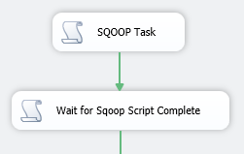

SQOOP Task source

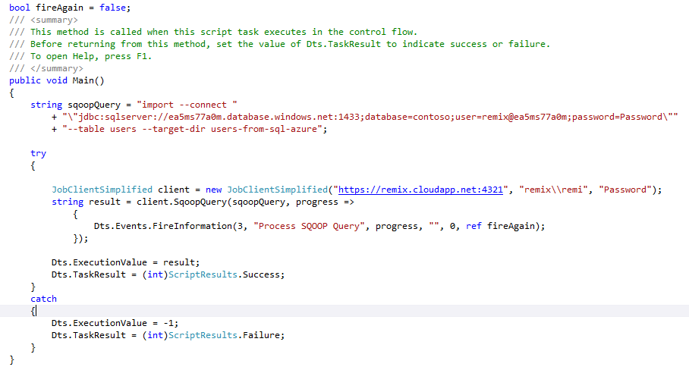

Using the JobClientSimplified class, the SqoopQuery method takes a query and another optional parameter to subscribe to a report progress. In this sample, the goal is to import the users table from a SQL Azure Database named contoso*,* as the query describes it.

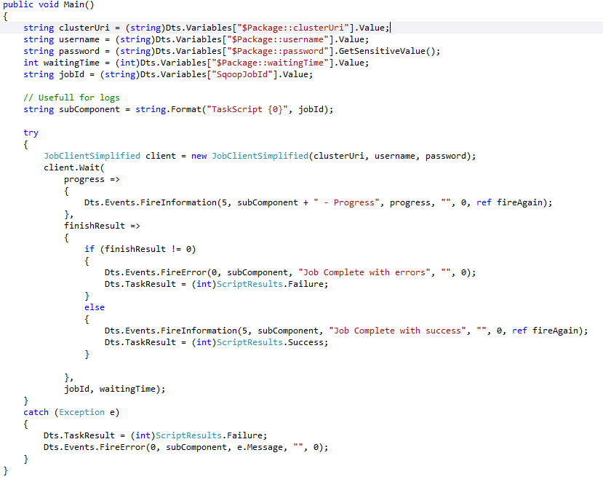

The final script task allows to log Hadoop job progression and to wait for completion thanks to the job ID passed in as a parameter.

### Local storage to/from Hadoop storage

From a cluster head node, it is possible to copy local data to HDFS and vice versa.

Local files can be NTFS files available on the local network.

Note that UNC path are not supported

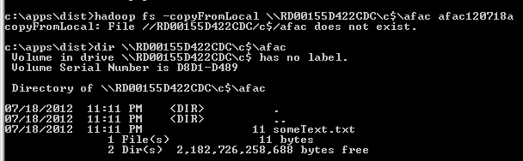

But fortunately mapping a drive may be a workaround

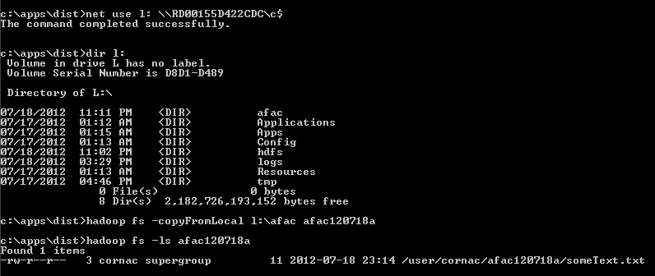

When the Hadoop cluster is connected to SSIS through the Internet only, the files to copy do not reside in the same LAN as the head node so we wouldn’t use that mechanism.

To run more advanced commands on the server, you may also use Remote Windows PowerShell. SSIS can run Windows PowerShell as previously covered.

To enable and use Remote Windows PowerShell, refer to the following blog posts:

* “Hey, Scripting Guy! Tell Me About Remoting in Windows PowerShell 2.0” (*http://blogs.technet.com/b/heyscriptingguy/archive/2009/10/29/hey-scripting-guy-october-29-2009.aspx*),
* “Configure PowerShell Remoting and Use Remote Commands” (*http://blogs.technet.com/b/heyscriptingguy/archive/2011/11/16/configure-powershell-remoting-and-use-remote-commands.aspx*),
* And “Learn How to Manage Remote PowerShell Sessions” (*http://blogs.technet.com/b/heyscriptingguy/archive/2011/11/17/learn-how-to-manage-remote-powershell-sessions.aspx*).

### SSIS to Windows Azure SQL Database

SSIS does not currently leverage the Windows Azure SQL Database retry mechanism, but this can be achieved by developing a custom destination component (see the eponym MSDN article, *http://msdn.microsoft.com/en-us/library/ms135899.aspx*) or by adding custom logic in SSIS.

## Which Data transfer mechanism to use with SSIS

### Synopsis

After having discussed different ways to transfer data to and from Hadoop in the previous, the synopsis can be updated as follows:



### Scenarios Criteria

This section details the different criteria used to define scenarios that will be discussed afterwards.

#### Deployment options

The deployment options lead to four important scenarios generated by two criteria:

1. Criterion 1: Hadoop storage
   * [ASV]: Hadoop cluster leverages Cloud Storage (ASV),
   * [HDFS]: Hadoop cluster uses only HDFS (it is on premises or a permanent cluster in the cloud).
2. Criterion 2: Network link between Hadoop and the BI platform
   * [LAN]: Data source and Hadoop cluster are in the same LAN,
   * [Internet]: Data source and Hadoop cluster are only connected thru Internet.

#### Data Format

Data can be unstructured or tabular.

Tabular data is typically stored in relational tables, but it can also live in files (CSV files for example). HIVE External tables expose folders containing tabular data (possibly in many files that have the same structure) as relational tables.

Of course, as an ETL tool, SSIS can transform data from unstructured to tabular or vice versa.

In the tables of the following sections entitled “Scenario: XXX”, it is assumed that both source and destination are either both unstructured or both tabular. Hadoop cluster would typically be used to transform unstructured data to tabular data in order to make it more easily consumable by a BI platform.

#### Transfer Direction

Another criterion is the transfer direction that can be to or from Hadoop storage (either HDFS or ASV, depending on the deployment option).

### Scenario: Windows Azure Storage + Internet

This deployment option would be for instance a Hadoop cluster on Windows Azure, and the BI platform on premises.

For tabular data, on the Hadoop side, it is recommended that you use HIVE external tables on ASV so that data is still available when the cluster is removed. There is also an option to store HIVE metadata in Windows Azure SQL Database for the same reason.

|  |  |  |
| --- | --- | --- |
| Transfer direction  Data Format | Data source to Hadoop | Hadoop to data destination |
| Unstructured | SSIS custom destination component that leverages Windows Azure block Blob storage API | SSIS custom source component that leverages Windows Azure block Blob storage API |
| Tabular | Same as unstructured  SQOOP (1) | Same as unstructured  Hive ODBC  SQOOP (1) |

(1) Only when the data source or data destination is exposed to the Internet, which is the case for Windows Azure SQL Database, provided the proper firewall settings were completed.

### Scenario: Windows Azure Storage + LAN

This deployment option would be a Hadoop cluster on Windows Azure along with a BI platform hosted on Windows Azure IaaS as well. The BI platform could also be on premises and linked to the Hadoop cluster on Windows Azure thru VPN.

For tabular data, on the Hadoop side, it is recommended that you use HIVE external tables on ASV so that data is still available when the cluster is removed. There is also an option to store HIVE metadata in Windows Azure SQL Database for the same reason.

|  |  |  |
| --- | --- | --- |
| Transfer direction  Data Format | Data source to Hadoop | Hadoop to data destination |
| Unstructured | SSIS custom destination component that leverages Windows Azure block Blob storage API | SSIS custom source component that leverages Windows Azure block Blob storage API |
| Tabular | Same as unstructured  SQOOP  Hive load data | Same as unstructured  SQOOP  Hive ODBC |

### Scenario: HDFS + LAN

This deployment option would be a Hadoop cluster and the BI platform on premises, both in the same LAN. There may be other options like having everything in Windows Azure in the same virtual network, or having one part in Windows Azure and the other part on premises with a VPN between the two.

|  |  |  |
| --- | --- | --- |
| Transfer direction  Data Format | Data source to Hadoop | Hadoop to data destination |
| Unstructured | SSIS custom destination that leverages HDFS Streaming  Hadoop fs -copyFromLocal | SSIS custom source component that leverages HDFS Streaming  Hadoop fs –copyToLocal |
| Tabular | SQOOP  Hive load data  Same as unstructured | SQOOP  Hive ODBC  Same as unstructured |

### Scenario: HDFS + Internet

Having a permanent Hadoop cluster on Windows Azure and a BI platform on premises, without a VPN between the two would be the most obvious case for this scenario. Other cases could be having a Hadoop cluster on premises and the BI platform on Windows Azure, or both on premises, but not in the same LAN (like with two different companies for instance).

|  |  |  |
| --- | --- | --- |
| Transfer direction  Data Format | Data source to Hadoop | Hadoop to data destination |
| Unstructured | SSIS custom destination that leverages HDFS Streaming | SSIS custom destination that leverages HDFS Streaming |
| Tabular | Same as unstructured  SQOOP (1) | Hive ODBC driver  SQOOP (1)  Same as unstructured |

(1) Only when the data source or data destination is exposed to the Internet, which is the case for Windows Azure SQL Database, provided the proper firewall settings were completed.

# Performance

## SSIS

SSIS can handle high volumes of data, provided that best practices are used. For instance, an article[21] dated March 2009 explains how 1 TB of data was loaded in 30 minutes with SSIS.

Best practices are documented. Here are a few interesting references:

* “SQL Server Integration Services (SSIS) Best Practices” (*http://blogs.technet.com/b/sqlman/archive/2010/01/02/sql-server-integration-services-ssis-best-practices.aspx*)
* “Top 10 SQL Server Integration Services Best Practices” (*http://sqlcat.com/sqlcat/b/top10lists/archive/2008/10/01/top-10-sql-server-integration-services-best-practices.aspx*)
* “Designing and Tuning for Performance your SSIS packages in the Enterprise (SQL Video Series)” (*http://sqlcat.com/sqlcat/b/presentations/archive/2009/05/02/designing-and-tuning-for-performance-your-ssis-packages-in-the-enterprise-sql-video-series.aspx*)

The Microsoft Customer Advisory Team (CAT) who wrote a number of these documents works on complex customer scenarios and provides documentation back to the community in terms of best practices.

Besides the SSIS best practices, the following sections discuss specific considerations to take into account while using SSIS together with Hadoop.

## Windows Azure Blob Storage

ASV is based on Windows Azure block blob storage. Each block blob has a maximum size of 200 GB[22].

When measuring performance against blob storage, it is recommended to let the test last more than a few minutes because the system improves as it learns over time.

An interesting blog post give “Windows Azure Storage Abstractions and their Scalability Targets” (*http://blogs.msdn.com/b/windowsazurestorage/archive/2010/05/10/windows-azure-storage-abstractions-and-their-scalability-targets.aspx*).

## HIVE

Some recommendations on performance for SSIS include avoiding the use of SELECT * and instead using a SELECT statement that includes the column names. This is true when the source is a classic RDBMS like SQL Server database, but the story is completely different with HIVE.

The general principle of HIVE is to expose Hadoop Map/Reduce functionalities through an SQL like language.

Thus, when you issue a command like the following, a map/reduce job will trigger to remove columns c, d and e from the SomeHiveTable data set that has 5 columns (a, b, c, d, e), and send back only columns a and b.

SELECT a, b FROM SomeHiveTable

On the other hand, when a statement like the following is issued, no Map/Reduce job is needed.

SELECT * FROM SomeHiveTable

Also note that you can limit the number of records return with the LIMIT keyword. A statement such as the following will not trigger a Hadoop Map/Reduce job either.

SELECT * FROM SomHiveTable LIMIT 2000

Thus, with HIVE, you may get better execution time by issuing SELECT * rather than selecting specific columns. In cases where selecting only a few columns reduces a lot of the data to transfer, it may still be interesting to select only a few columns. Moreover, the cost of egress data transfer from a Windows Azure data center may also be a decision criterion.

# Conclusion

In the big data domain, Hadoop and the Microsoft Business Intelligence platform are very complementary. At the edge of the two, SQL Server’s ETL tool, SSIS, plays an important role in transferring data between Hadoop, the BI platform and other data sources and destinations.

SSIS enables automation and data transfers that can be authored either with graphic tools, or XML, and run in production as Windows Server services, with all the needed management and monitoring tools.

# Appendix

## Resources

* Hadoop on Azure REST API (*https://github.com/bradsa/hadooponazure-rest-api*)
* “HADOOP, HIVE, ODBC, SSIS, SQL Azure, SQL Azure Reporting” (*http://blogs.msdn.com/b/benjguin/archive/2012/03/07/hadoop-hive-odbc-ssis-sql-azure-sql-azure-reporting.aspx*)
* “Moving data from Hive table in MS Hadoop into SQL Server using SSIS Server.” (*http://alexeikh.wordpress.com/2012/05/03/moving-data-from-hive-table-in-ms-hadoop-into-sql-server-using-ssis-server/*)
* “Using SQOOP for moving data between HADOOP and SQL Server” (*http://alexeikh.wordpress.com/2012/05/03/using-sqoop-for-moving-data-between-hadoop-and-sql-server/*)
* Carl Nolan's blog on .NET and Map/Reduce (*http://blogs.msdn.com/b/carlnol*)
* “BI and Big Data–the best of both worlds!” (*http://dennyglee.com/2012/03/01/bi-and-big-datathe-best-of-both-worlds/*)

## Abbreviations

|  |  |  |
| --- | --- | --- |
| **Abbreviation** | **Stands for** | **Explanations** |
| ASV | Azure Storage Vault | Windows Azure Blob storage exposed as Hadoop storage |
| BI | Business Intelligence |  |
| ETL | Extract Transform Load |  |
| GAC | Global Assembly Cache | A central repository on Windows where .NET assemblies can be deployed and referenced by any application on the same machine. |
| MSDN | Microsoft Developer Network | This is a subscription for developers.  It is also a website where all Microsoft documentation for developers is available. It can be found at *http://msdn.microsoft.com*. |
| RDBMS | Relational Database Management System |  |
| UNC | Uniform Naming Convention | Syntax for network paths in Windows. Example: \\myserver\myshare\myfolder\myfile.dat  See “Path (computing)” (*http://en.wikipedia.org/wiki/Path_(computing)*). |
| VPN | Virtual Private Network | An network tunneling technique |

## HADOOP, HIVE, ODBC, SSIS, SQL Azure, SQL Azure Reporting

Here is an adapted copy of a blog post*[23]* by a co-author of this paper. Note that when that post was written, Windows Azure SQL Database was called SQL Azure.

In a previous post, I talked about analyzing 1 TB of IIS logs with JavaScript thru Hadoop Map/Reduce (*http://blogs.msdn.com/b/benjguin/archive/2012/02/09/analyzing-1-tb-of-iis-logs-with-hadoop-map-reduce-on-azure-with-javascript-analyse-d-1-to-de-journaux-iis-avec-hadoop-map-reduce-en-javascript.aspx*).

In this post, let’s see how to copy and use the result of these jobs to Windows Azure SQL database.

First of all, from 1 TB of IIS logs, we had a result of less than 100 GB for the headers and details, so having this data in Windows Azure SQL database (or SQL Server) will be more efficient than keeping it in Hadoop: Hadoop Map/Reduce is a world of batches that can handle bigger and bigger amounts of data linearly while Windows Azure SQL database is interactive (but requires Windows Azure SQL database federations to scale linearly).

The steps are the following:

* Create a Windows Azure SQL database
* Create HIVE metadata
* Open ODBC port
* Install ODBC driver
* Create SSIS package
* Run SSIS package
* Create and run a Windows Azure SQL database Report on top of database

Create a Windows Azure SQL database

A Windows Azure SQL database can be created as explained in the blog post “Create a SQL Azure database” (*http://blogs.msdn.com/b/benjguin/archive/2012/03/06/create-a-sql-azure-database-cr-233-er-une-base-sql-azure.aspx*).

Note that if one already has a Windows Azure SQL database, he can reuse it but he might have to change its size. For instance to let a Windows Azure SQL database grow from 1 GB to 150 GB, the following statement should be issued against the master database in the same Windows Azure SQL database server:

ALTER DATABASE demo MODIFY (MAXSIZE = 150 GB, EDITION='business')

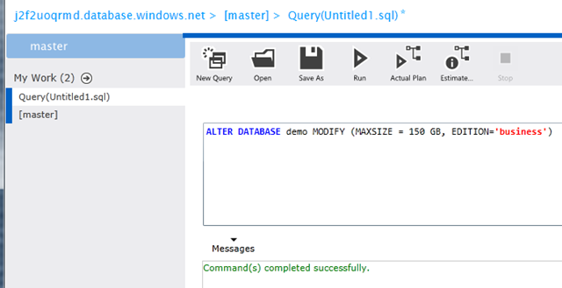

Create HIVE metadata

HIVE can store its data in HDFS with a variety of format. It can also reference existing data without directly managing it. This kind of storage is called external tables. In our case, we want to expose the iislogsH and iislogsD HDFS folders as HIVE tables. Here how the folders look in HDFS:

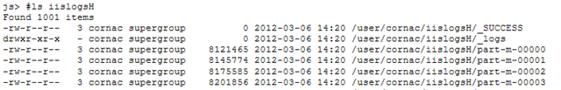

(…)

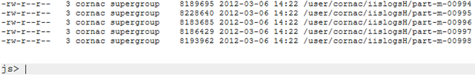

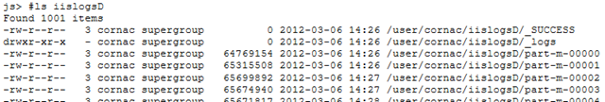

(…)

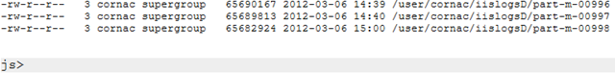

js> #tail iislogsH/part-m-00998

731g2x183 2012-01-25 19:01:05 2012-01-25 19:22:11 16

872410056 a34175aac900ed11ea95205e6c600d461adafbac test1833g4x659 2012-01-27 13:23:31 2012-01-27 13:39:28 4

872410676 a34182f009cea37ad87eb07e5024b825b0057fff test1651hGx209 2012-01-28 18:05:45 2012-01-28 18:41:37 7

872411200 a341afd002814dcf39f9837558ada25410a96669 test2250g4x61 2012-01-27 01:04:45 2012-01-27 01:23:19 5

872412076 a341b71e15a5ba5776ed77a924ddaf49d89bab54 test4458gAx34 2012-02-02 19:00:07 2012-02-02 19:09:12 10

872412288 a341c30edf95dfd0c43a591046eea9eebf35106e test2486g4x352 2012-01-27 17:05:52 2012-01-27 17:27:54 2

872412715 a341cb284b21e10e60d895b360de9b570bee9444 test3126g2x205 2012-01-25 13:07:47 2012-01-25 13:49:20 4

872413239 a341cc54e95d23240c4dfc4455f6c8af2a621008 test0765g7x99 2012-01-30 00:08:04 2012-01-30 00:43:17 5

872414168 a341d37eb48ae06c66169076f48860b1a3628d49 test0885g4x227 2012-01-27 18:02:40 2012-01-27 18:11:12 11

872414800 a341d8762f0d7e1e70ced16ce10786ea50ef3ca7 test2471hHx165 2012-01-29 20:00:58 2012-01-29 20:40:24 6

js> #tail iislogsD/part-m-00998

9 a341d8762f0d7e1e70ced16ce10786ea50ef3ca7 20:40:24 /

872414323 a341d8762f0d7e1e70ced16ce10786ea50ef3ca7 20:07:49 /cuisine-francaise/huitres

872414402 a341d8762f0d7e1e70ced16ce10786ea50ef3ca7 20:00:58 /cuisine-francaise/gateau-au-chocolat-et-aux-framboises

872414510 a341d8762f0d7e1e70ced16ce10786ea50ef3ca7 20:29:52 /cuisine-francaise/gateau-au-chocolat-et-aux-framboises

872414618 a341d8762f0d7e1e70ced16ce10786ea50ef3ca7 20:39:51 /Users/Account/LogOff

872414692 a341d8762f0d7e1e70ced16ce10786ea50ef3ca7 20:09:52 /cuisine-francaise/gateau-au-chocolat-et-aux-framboises

872414900 a341db58e7be1b37828ed5591ba17c251c96a16a 03:00:23 /Modules/Orchard.Localization/Styles/orchard-localization-base.css

872415019 a341db58e7be1b37828ed5591ba17c251c96a16a 03:00:57 /Users/Account/LogOff

872415093 a341db58e7be1b37828ed5591ba17c251c96a16a 03:00:12 /Themes/Classic/Styles/Site.css

872415177 a341db58e7be1b37828ed5591ba17c251c96a16a 03:00:56 /

872415231 a341db58e7be1b37828ed5591ba17c251c96a16a 03:00:44 /Core/Shapes/scripts/html5.js

The following statements will expose the folders as HIVE external tables:

CREATE EXTERNAL TABLE iisLogsHeader (rowID STRING, sessionID STRING, username STRING, startDateTime STRING, endDateTime STRING, nbUrls INT)

ROW FORMAT DELIMITED

    FIELDS TERMINATED BY '\t'

    LINES TERMINATED BY '\n'

STORED AS TEXTFILE

LOCATION '/user/cornac/iislogsH'

CREATE EXTERNAL TABLE iisLogsDetail (rowID STRING, sessionID STRING, HitTime STRING, Url STRING)

ROW FORMAT DELIMITED

    FIELDS TERMINATED BY '\t'

    LINES TERMINATED BY '\n'

STORED AS TEXTFILE

LOCATION '/user/cornac/iislogsD'

These statements can be entered in the HadoopOnAzure portal (*https://www.hadooponazure.com/*).



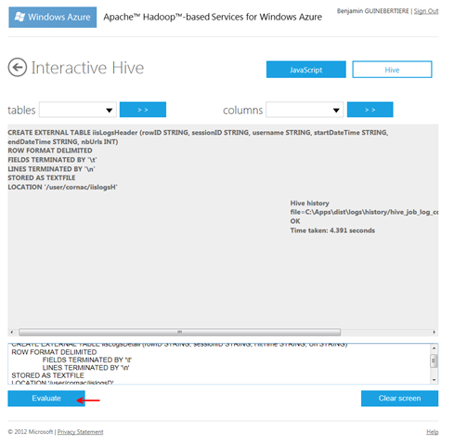

It is possible to check that data is exposed thru HIVE by issuing this kind of statement. Note that using SELECT * will not generate a map/reduce job because there is no need to change data before returning it.

SELECT * FROM iislogsheader LIMIT 20

[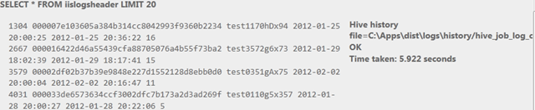](http://blogs.msdn.com/cfs-file.ashx/__key/communityserver-blogs-components-weblogfiles/00-00-00-46-20-metablogapi/8867.image_5F00_7E651012.png)

SELECT * FROM iislogsdetail LIMIT 20

[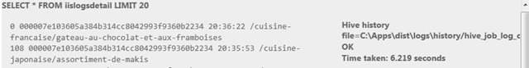](http://blogs.msdn.com/cfs-file.ashx/__key/communityserver-blogs-components-weblogfiles/00-00-00-46-20-metablogapi/2438.image_5F00_7E356052.png)

Open ODBC port

From HadoopOnAzure portal, go to the Open Ports tile and make sure ODBC port 10000 is open

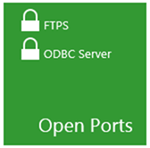



Install ODBC driver

On the server where SSIS will run, there must be the HIVE ODBC driver installed.

It can be installed from HadoopOnAzure portal, by clicking the “Downloads” tile and choosing the right MSI:



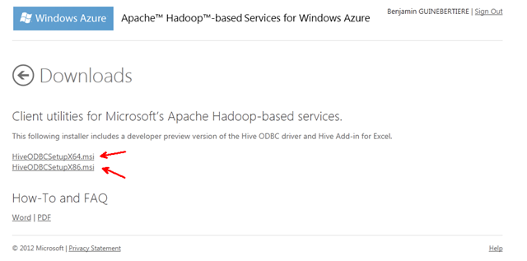

Create an SSIS Package

A general guidance on how to create an SSIS package to fill Windows Azure SQL database is available in the blog post “Use SSIS to push data to SQL Azure” (*http://blogs.msdn.com/b/benjguin/archive/2012/02/01/use-ssis-to-push-data-to-sql-azure-utiliser-ssis-pour-pousser-des-donn-233-es-vers-sql-azure.aspx*).

The user DSN (ODBC entry) can be created from Windows Control Panel.

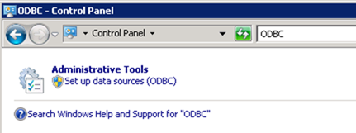

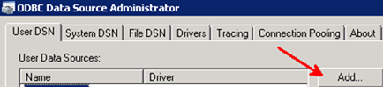

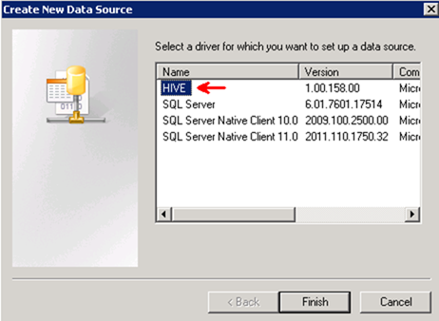

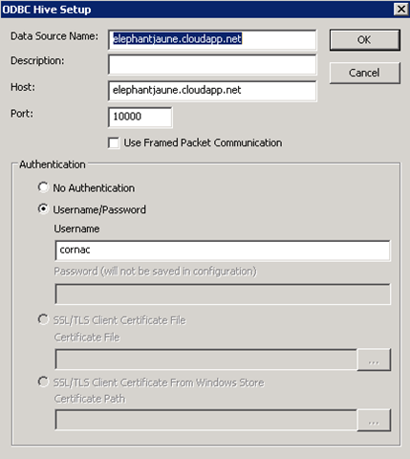

 To connect to HIVE thru ODBC, use an SSIS ODBC driver for ADO.NET

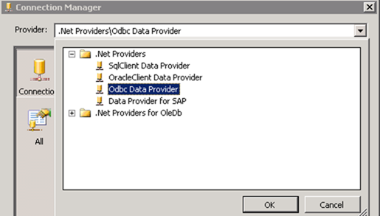

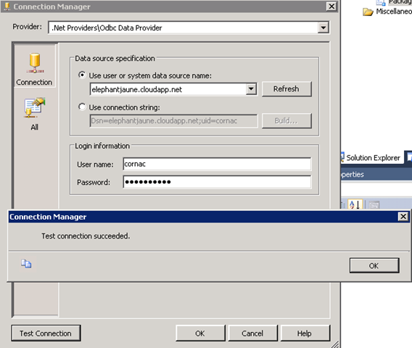

By default, the number of allowed errors is 1. You can change this value by selecting the data flow, then the control flow, and changing its MaximumErrorCount property.

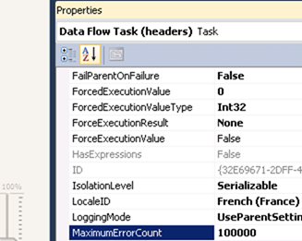

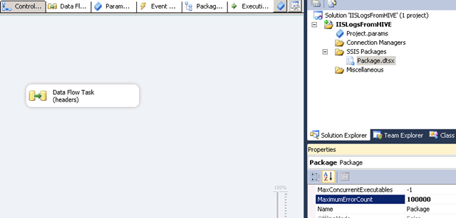

You can also change timeouts.

While creating the package, you may choose to have the destination tables created automatically. Here are the resulting tables schemas in SQL Azure (as screenshots).

As Hadoop MapReduce may generate rowid duplicates (in our case), remove the rowid constraint by dropping and recreating the tables with the code provided here (change is underlined). The principle is to leave original rowid on the Hadoop cluster and create new ones in SQL.

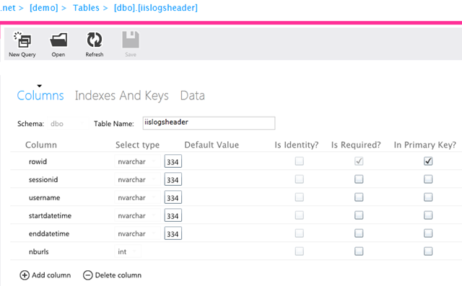

DROP TABLE [dbo].[iislogsheader]

GO

CREATE TABLE [dbo].[iislogsheader](

    [rowid] bigint IDENTITY(1,1) NOT NULL,

    [sessionid] [nvarchar](334) NULL,

    [username] [nvarchar](334) NULL,

    [startdatetime] [nvarchar](334) NULL,

    [enddatetime] [nvarchar](334) NULL,

    [nburls] [int] NULL,

PRIMARY KEY CLUSTERED

(

    [rowid] ASC

)

)

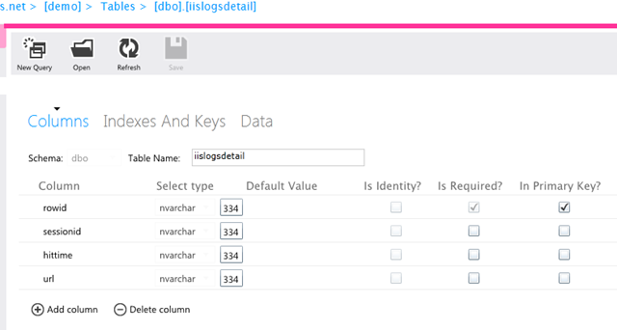

DROP TABLE [dbo].[iislogsdetail]

GO

CREATE TABLE [dbo].[iislogsdetail](

    [rowid] bigint IDENTITY(1,1) NOT NULL,

    [sessionid] [nvarchar](334) NULL,

    [hittime] [nvarchar](334) NULL,

    [url] [nvarchar](334) NULL,

PRIMARY KEY CLUSTERED

(

    [rowid] ASC

)

)

You must also remove the link between source and destination rowid columns as they are independent.

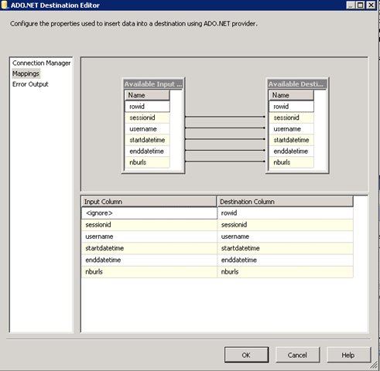

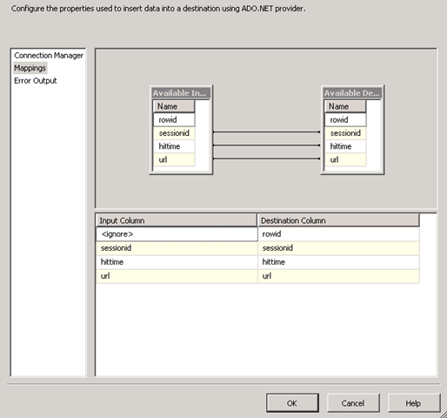

Run SSIS Package

The SSIS package can be deployed and run. In this sample, it is run from the debugger (F5 in Visual Studio).

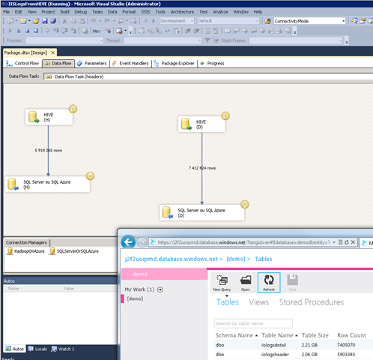

Note that the new name for SQL Azure is Windows Azure SQL database.

Create and run a SQL Azure Report

A report can be built on top of this SQL Azure database as explained in the blog post “SQL Azure Reporting Lab” (*http://blogs.msdn.com/b/benjguin/archive/2011/11/10/sql-azure-reporting-lab.aspx*).

For instance the report designer looks like this.

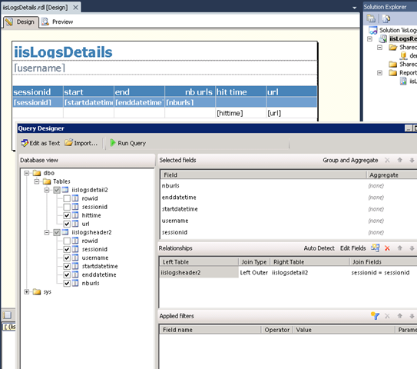

 And the report looks like this:

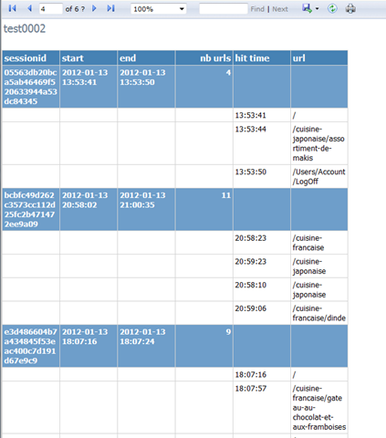

1. A famous example is Yahoo! With 2 PB of data in Hadoop and 24 TB of data in SQL Server Analysis Services (SSAS), as explained in the blog post “What’s so BIG about “Big Data”?” (*http://blogs.msdn.com/b/sqlcat/archive/2011/11/15/what-s-so-big-about-big-data.aspx*)
2. An article by Denny Lee shows how to do that. See “Hadoop on Azure Scenario: Query a web log via HiveQL” (*http://social.technet.microsoft.com/wiki/contents/articles/6628.aspx*)
3. See Apache™ Hadoop™-based Services for Windows Azure (*https://www.hadooponazure.com/*)
4. See Hadoop on Azure REST API (*https://github.com/bradsa/hadooponazure-rest-api*)
5. As of this writing, the client SDK Windows PowerShell cmdlets is available on the Hadoop on Azure website in the “downloads” category of the cluster dashboard: *https://[YourHadoopClusterName].cloudapp.net/Home/Downloads* (substitute your actual Hadoop Cluster name for *[YourHadoopClusterName]*).
6. For more details, please refer to “Building, Deploying, and Debugging Custom Objects” in SSIS documentation on MSDN at *http://msdn.microsoft.com/en-us/library/ms403356.aspx*.
7. For additional information, see “Why is PowerShell 2.0 installed in the same location as PowerShell 1.0?” (*http://stackoverflow.com/questions/5415259/why-is-powershell-2-0-installed-in-the-same-location-as-powershell-1-0*)
8. The project is at *http://incubator.apache.org/oozie/*. Two interesting articles enable to quickly understand it: “Introduction to Oozie” (*http://www.infoq.com/articles/introductionOozie*) and “Oozie by Example” (*http://www.infoq.com/articles/oozieexample*).
9. Hosting Hadoop on Windows Server in Amazon Web Services (AWS) would not have the same level of integration as Hadoop on Windows Azure, and it is out of the scope of this white paper.
10. Having a UNC path like \\myserver\myshare\myfolder\myfile.dat, one can issue the following command   
    net use S: \\myserver\myshare and then access the same file thru S:\myfolder\myfile.dat.
11. It is called an external table because data is not managed by HIVE engine, only metadata is.
12. The blog post was written by one of the authors of this paper
13. See “File Transfer Protocol Secure” (*http://fr.wikipedia.org/wiki/File_Transfer_Protocol_over_SSL*) for documentation on that protocol
14. During the preview, documentation is provided thru samples, wikis, and blog posts
15. Other samples include “An FTP secure client library for C#” (*http://www.codeproject.com/Articles/31624/An-FTP-secure-client-library-for-C*)
16. See “How to: Create a Public/Private Key Pair” (*http://msdn.microsoft.com/en-us/library/6f05ezxy.aspx*)
17. The Windows Azure Storage Services REST API Reference is available at the eponym page on MSDN (*http://msdn.microsoft.com/en-us/library/dd179355.aspx*).
18. The Windows Azure Managed Library Reference at the eponym page on MSDN (*http://msdn.microsoft.com/en-us/library/dd179380.aspx*).
19. If you have access to the Hadoop on Azure preview, you can find that sample at *https://www.hadooponazure.com/Account/SampleDetail/89*
20. See the WS-Management specification (*http://www.dmtf.org/standards/wsman*)
21. See “We Loaded 1TB in 30 Minutes with SSIS, and So Can You” (*http://technet.microsoft.com/en-us/library/dd537533(SQL.100).aspx*)
22. See “Understanding Block Blobs and Page Blobs” (*http://msdn.microsoft.com/en-us/library/ee691964.aspx*)
23. See “HADOOP, HIVE, ODBC, SSIS, SQL Azure, SQL Azure Reporting” (*http://blogs.msdn.com/b/benjguin/archive/2012/03/07/hadoop-hive-odbc-ssis-sql-azure-sql-azure-reporting.aspx*)